This non-functional “demo” of the Investing Models is just screen prints from the actual Excel spreadsheet. The rebalancing / comparison portfolio sheet, mutual fund picks, and allocation weights are not shown to avoid giving valuable content away for free.

To see better – use the bottom right slider to increase the Zoom number.

The first page shows the Conservative Fee-Based Model. There are five Models - Conservative, Moderately Conservative, Moderate, Moderately Aggressive, and Aggressive. This just shows what the Conservative Fee-Based Model looks like. Then there are over five ways to do it, for a total of 40+ Investment Models: Fee-based, All No-Load Mutual Funds, All Loaded Mutual Funds, all Index, and all ETF. The assumed 1.1% investment management fee is what an adviser would charge clients.

The next page is the exact same Model, but funded with benchmark indices to represent each asset class. This is how professionals compare themselves properly against the markets - this is very hard to beat!

The next pages have bar charts to easily compare YTD returns of all five Fee-based Models to both the same Index Models, and the markets. The yellow bars show the return differences. The rest of the charts show performance.

The page about Target Date Models is just what the Input sheet looks like.

The Models spreadsheet is not protected so you can make any changes you want to.

- Get monthly-updated mutual fund picks for all of the asset classes here on this website.
Great for do-it-yourself consumers who want an easy-to-manage investment portfolio.

The screen prints that say “Portfolio Statistics” and “Growth of $10,000” are not part of the Model Portfolios. They’re part of the Investment Benchmarking Software product.
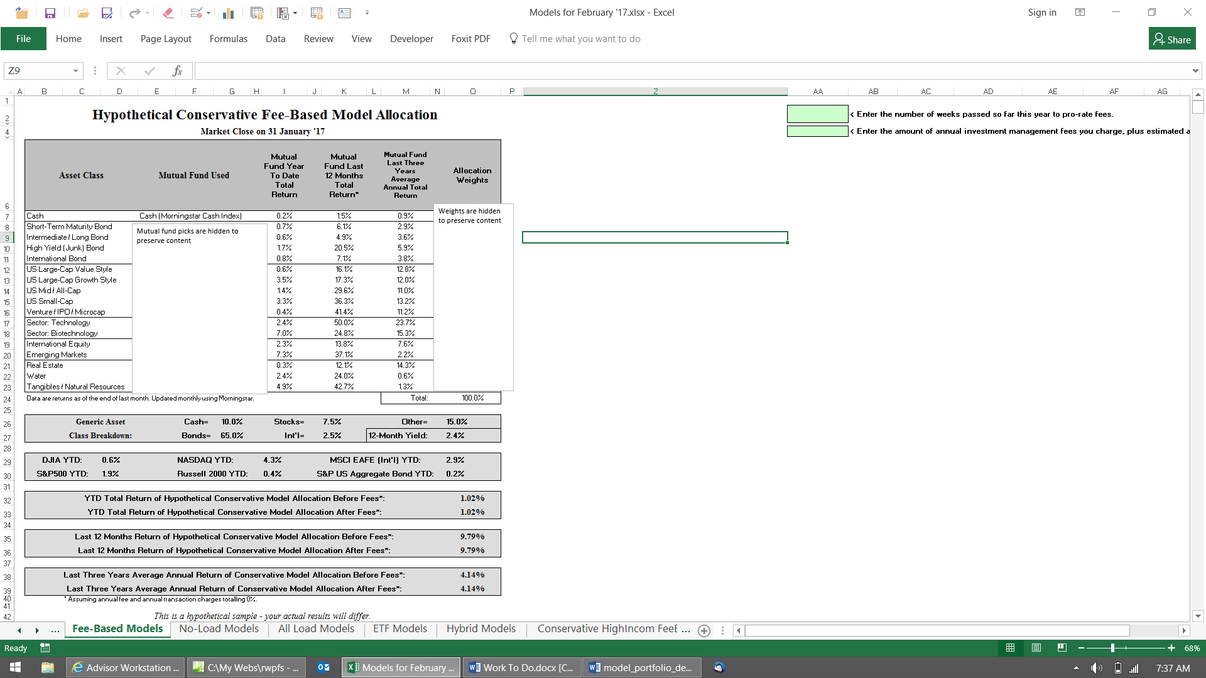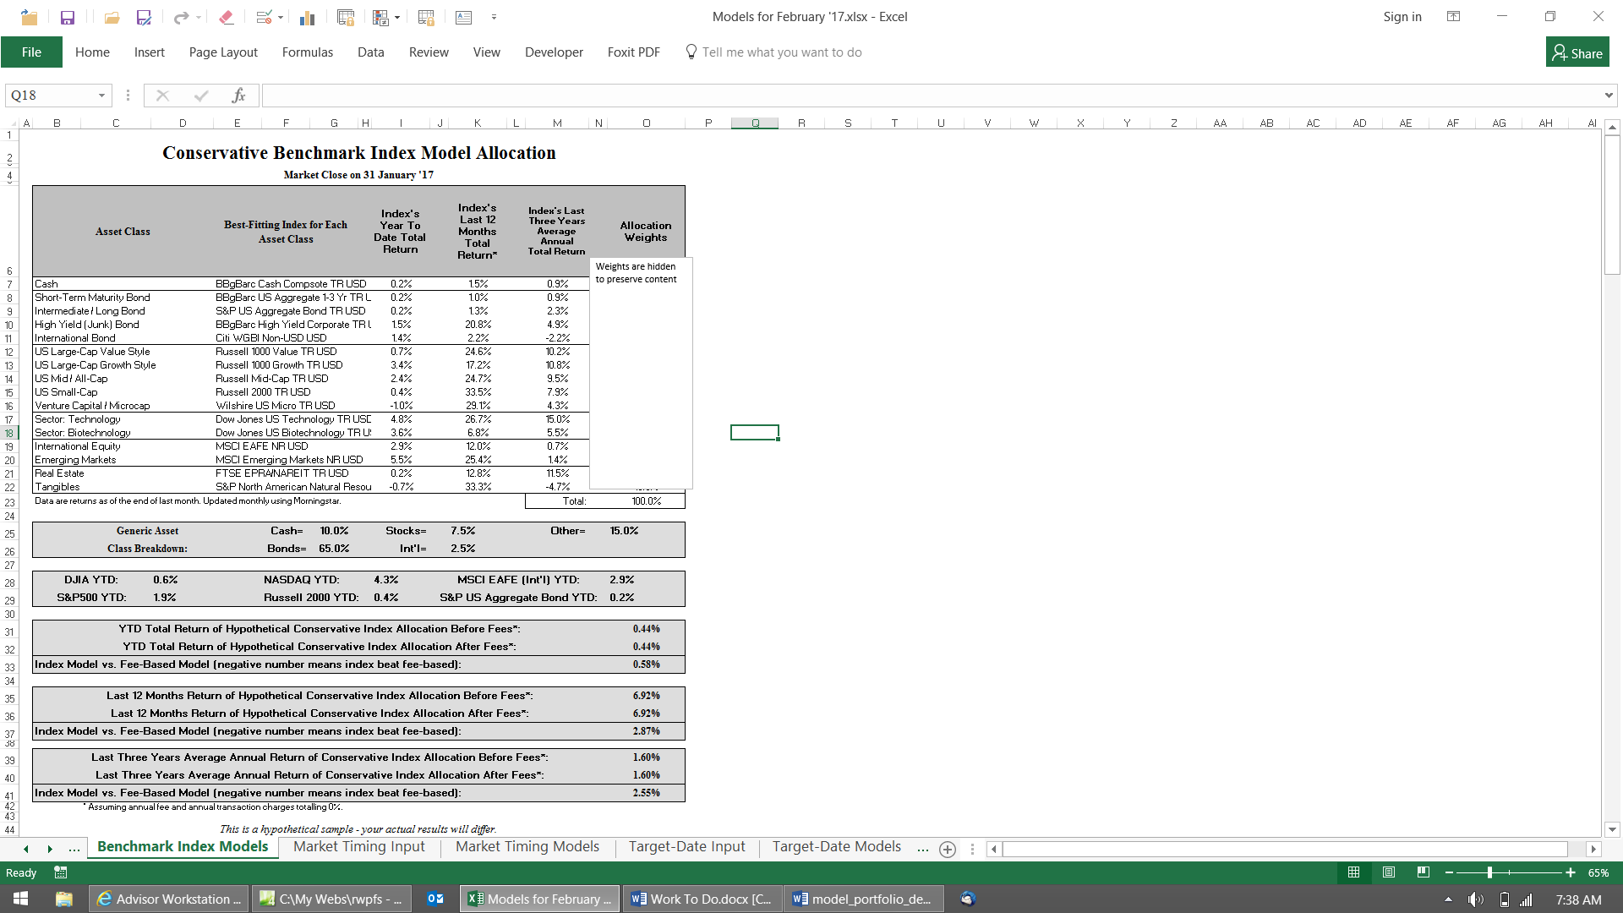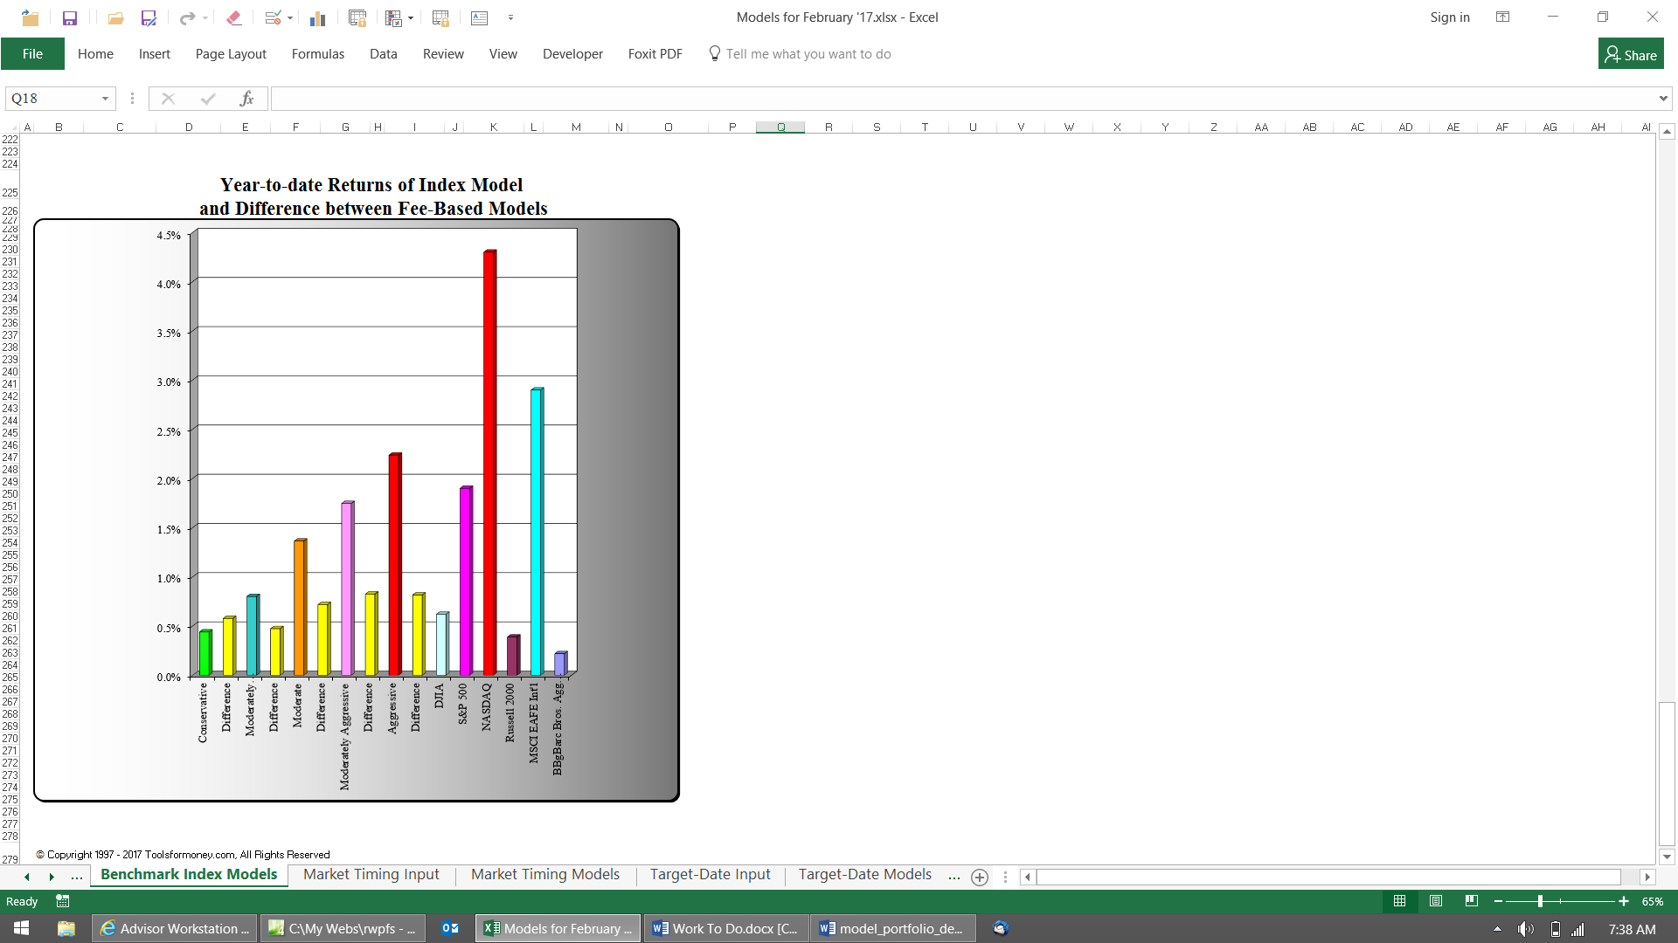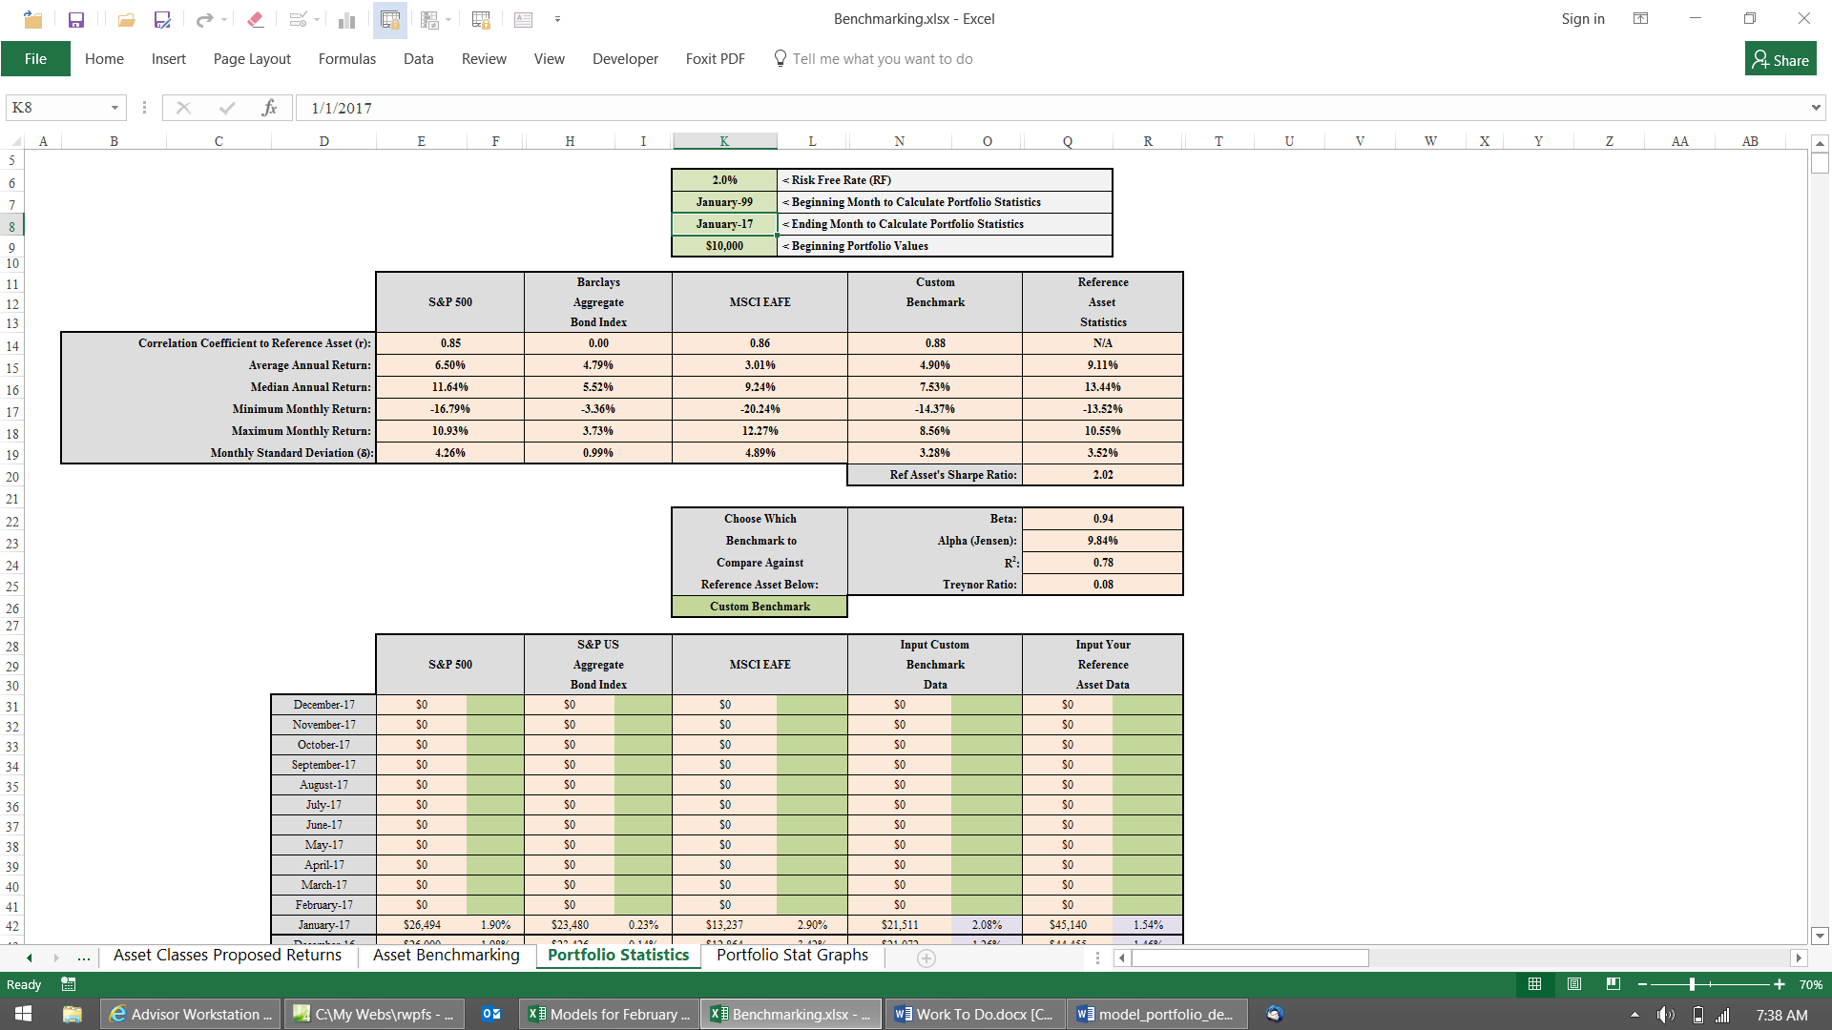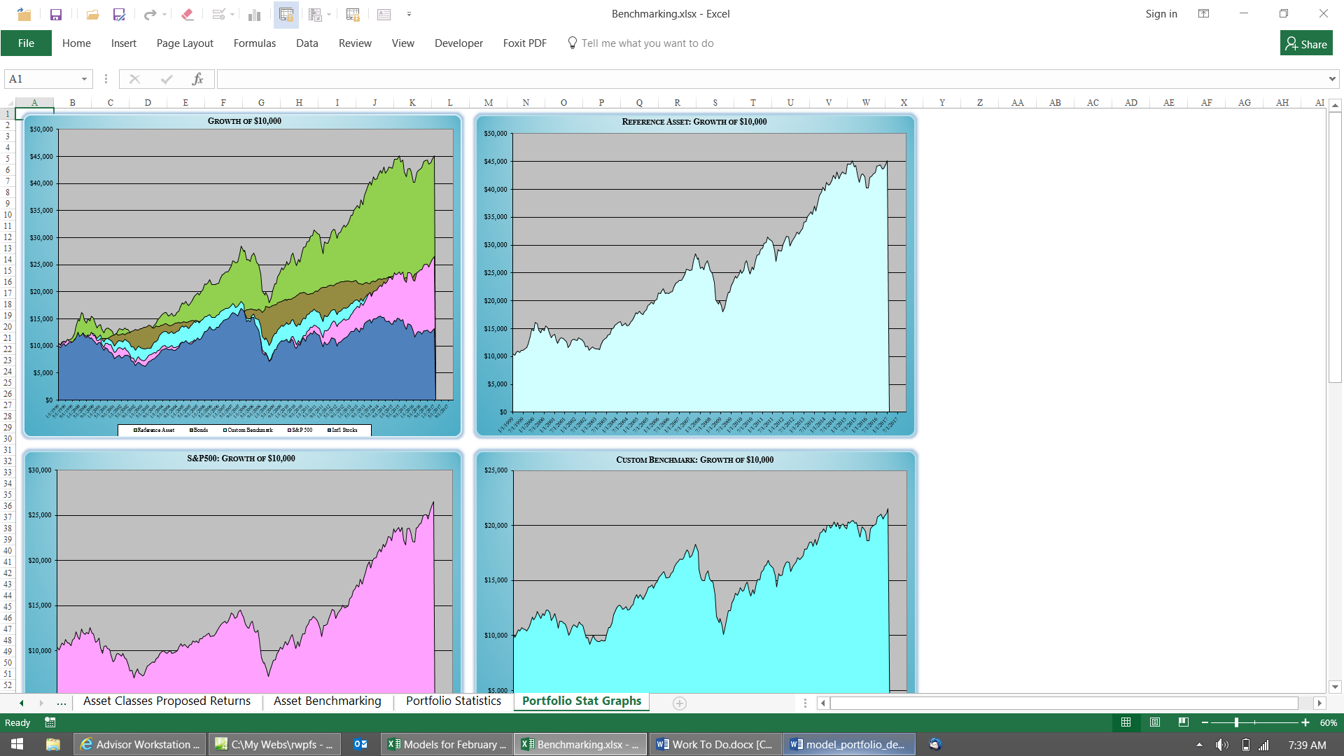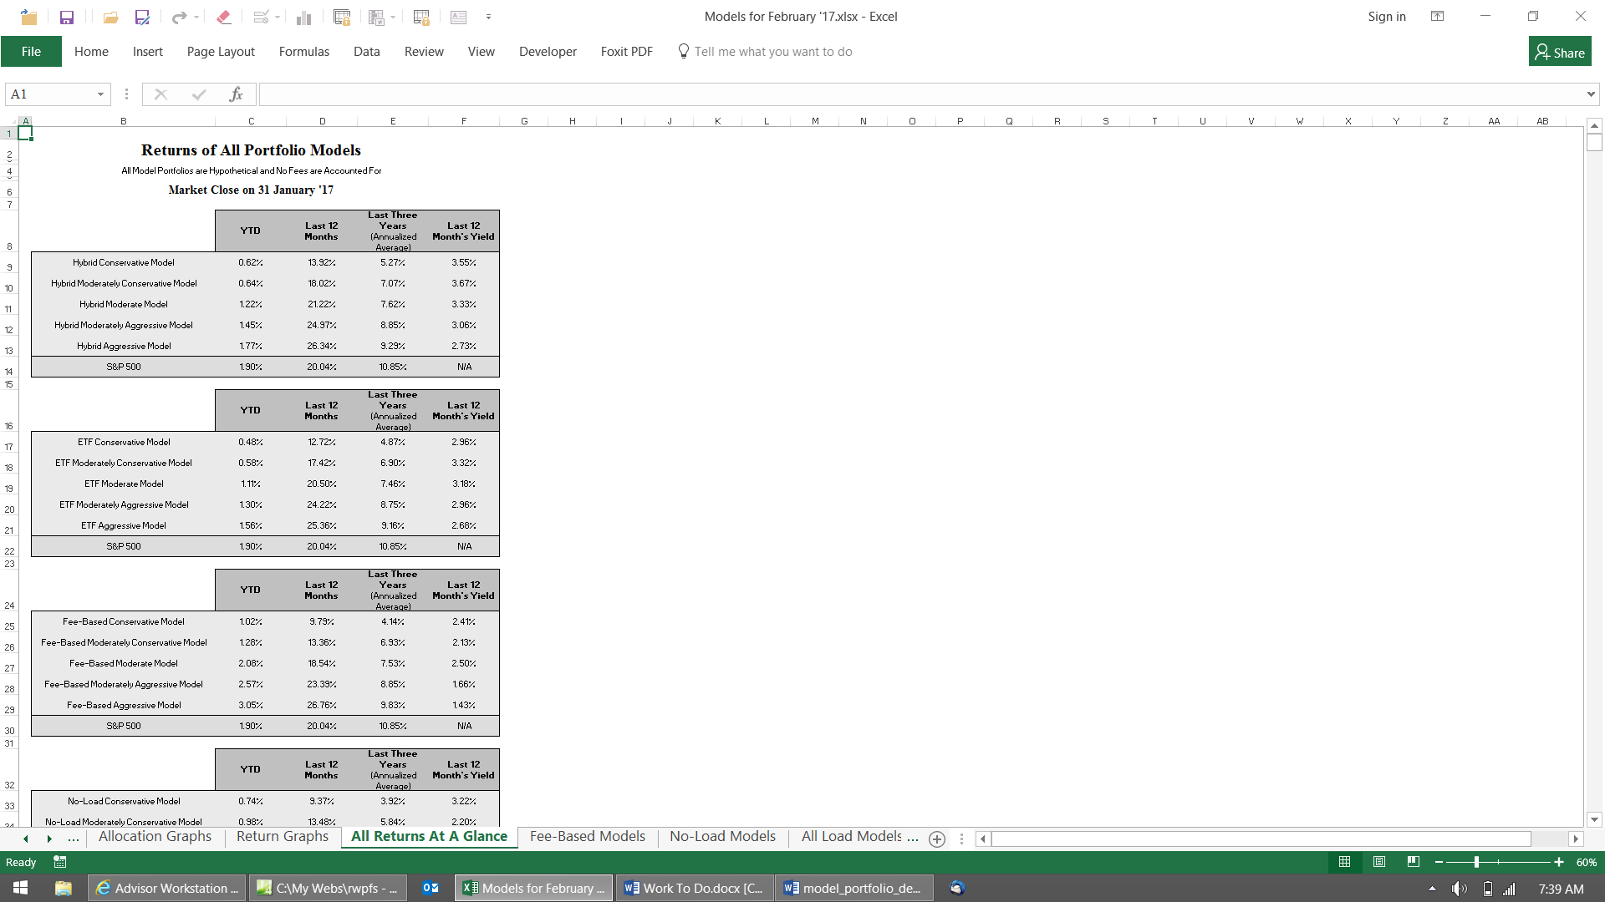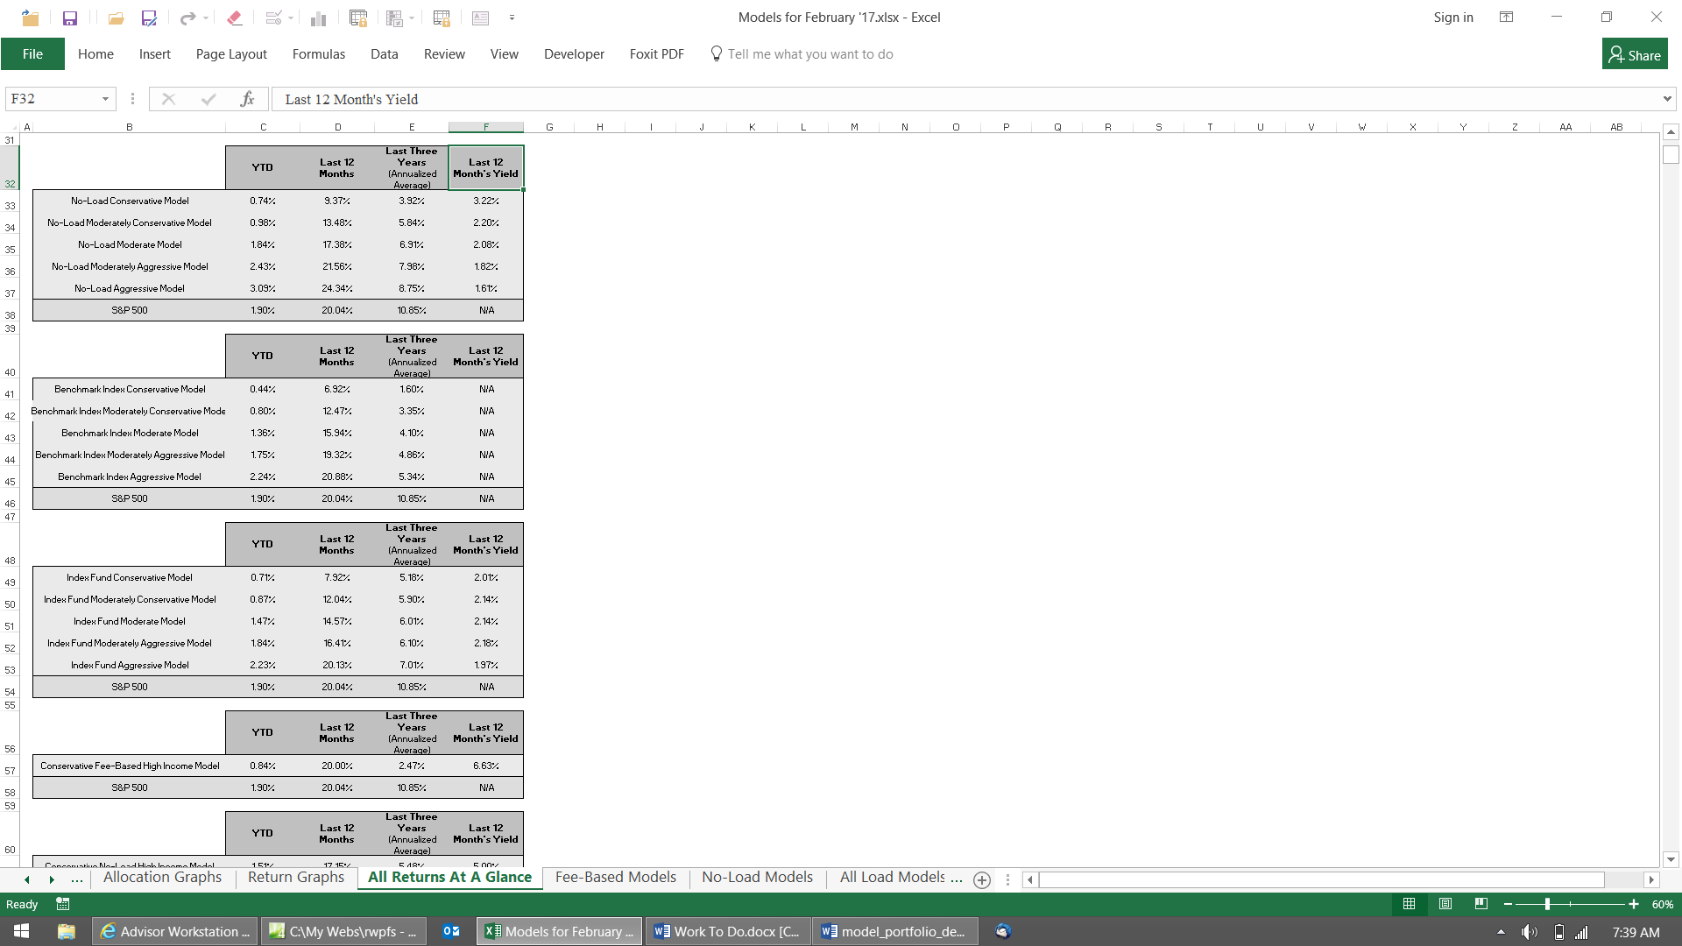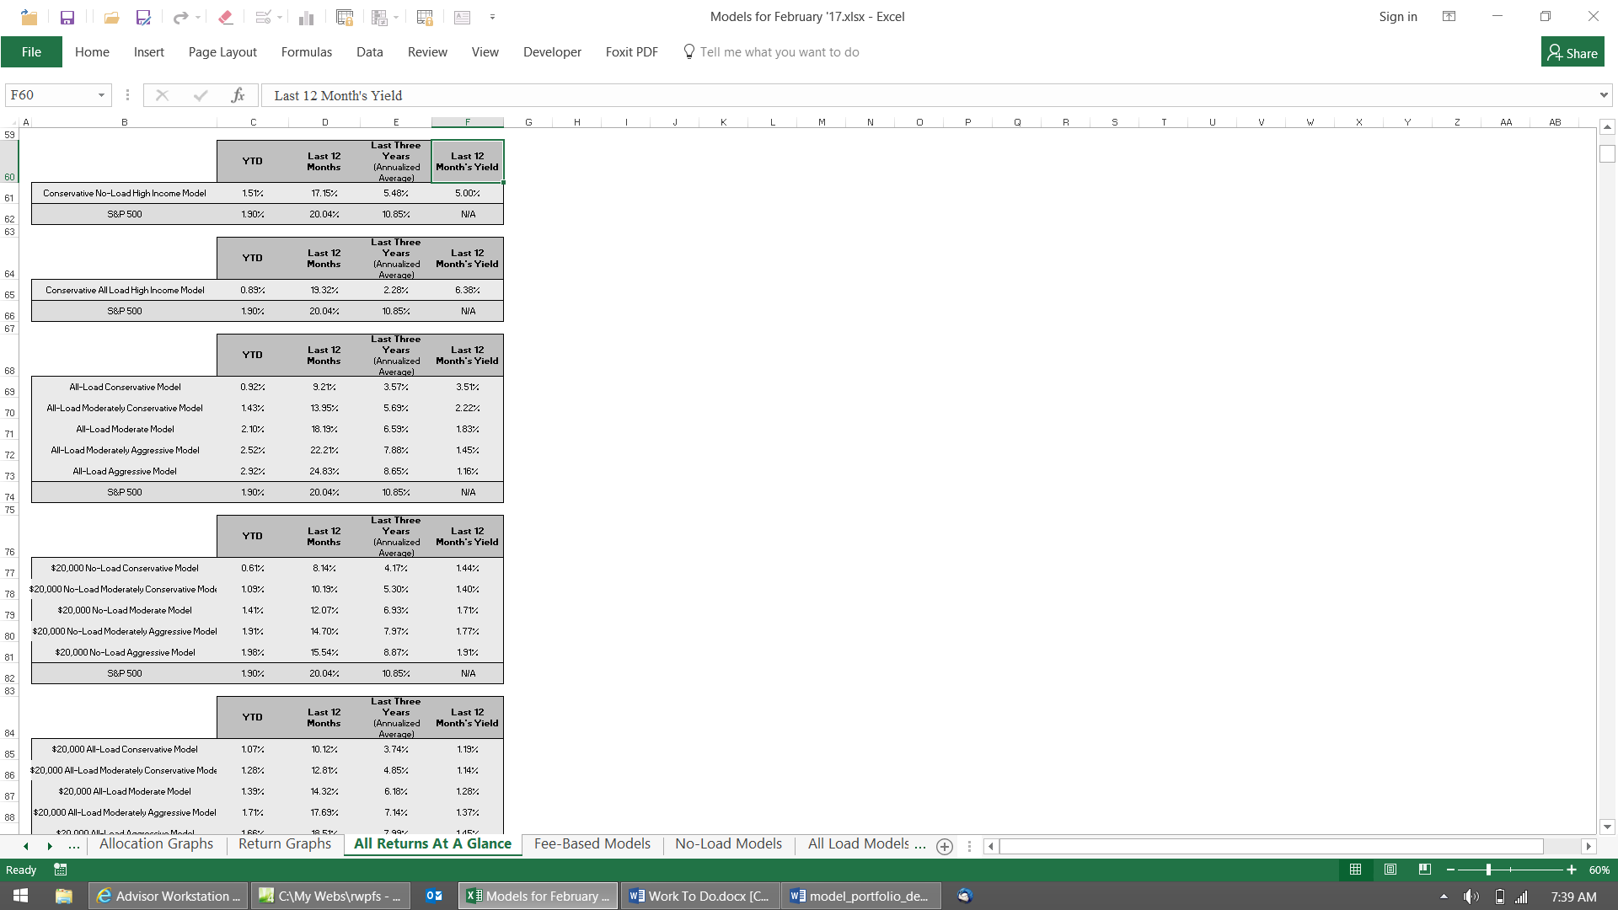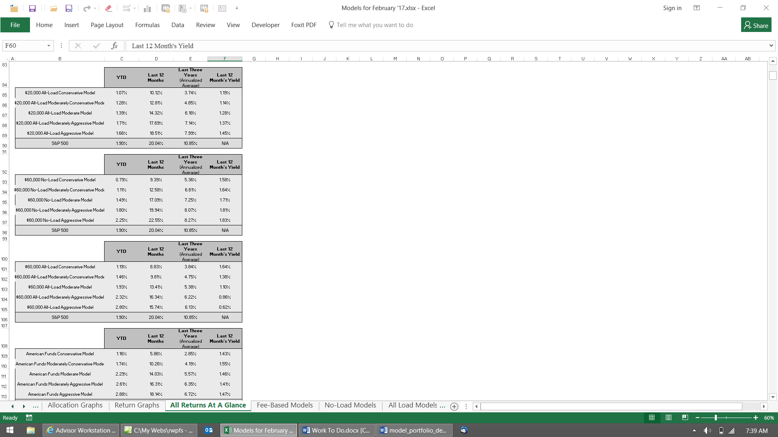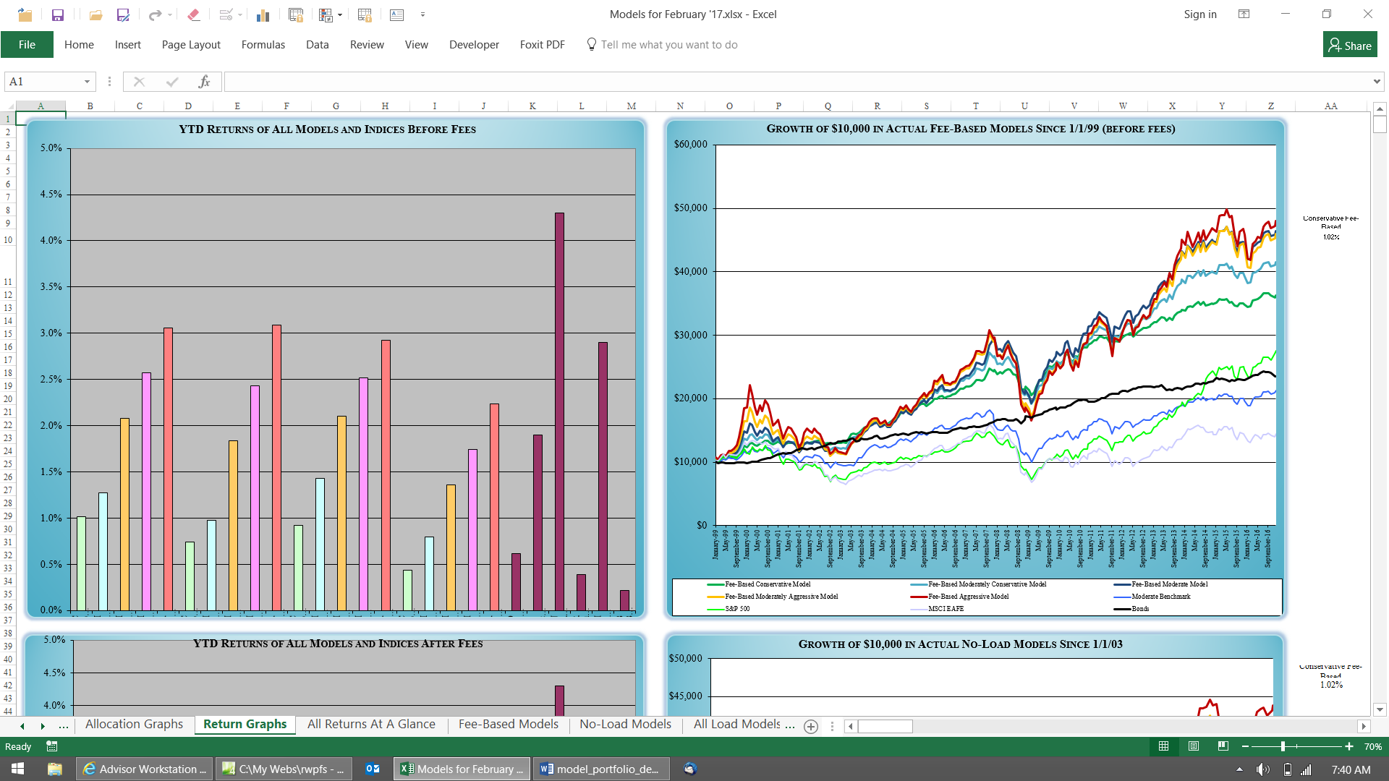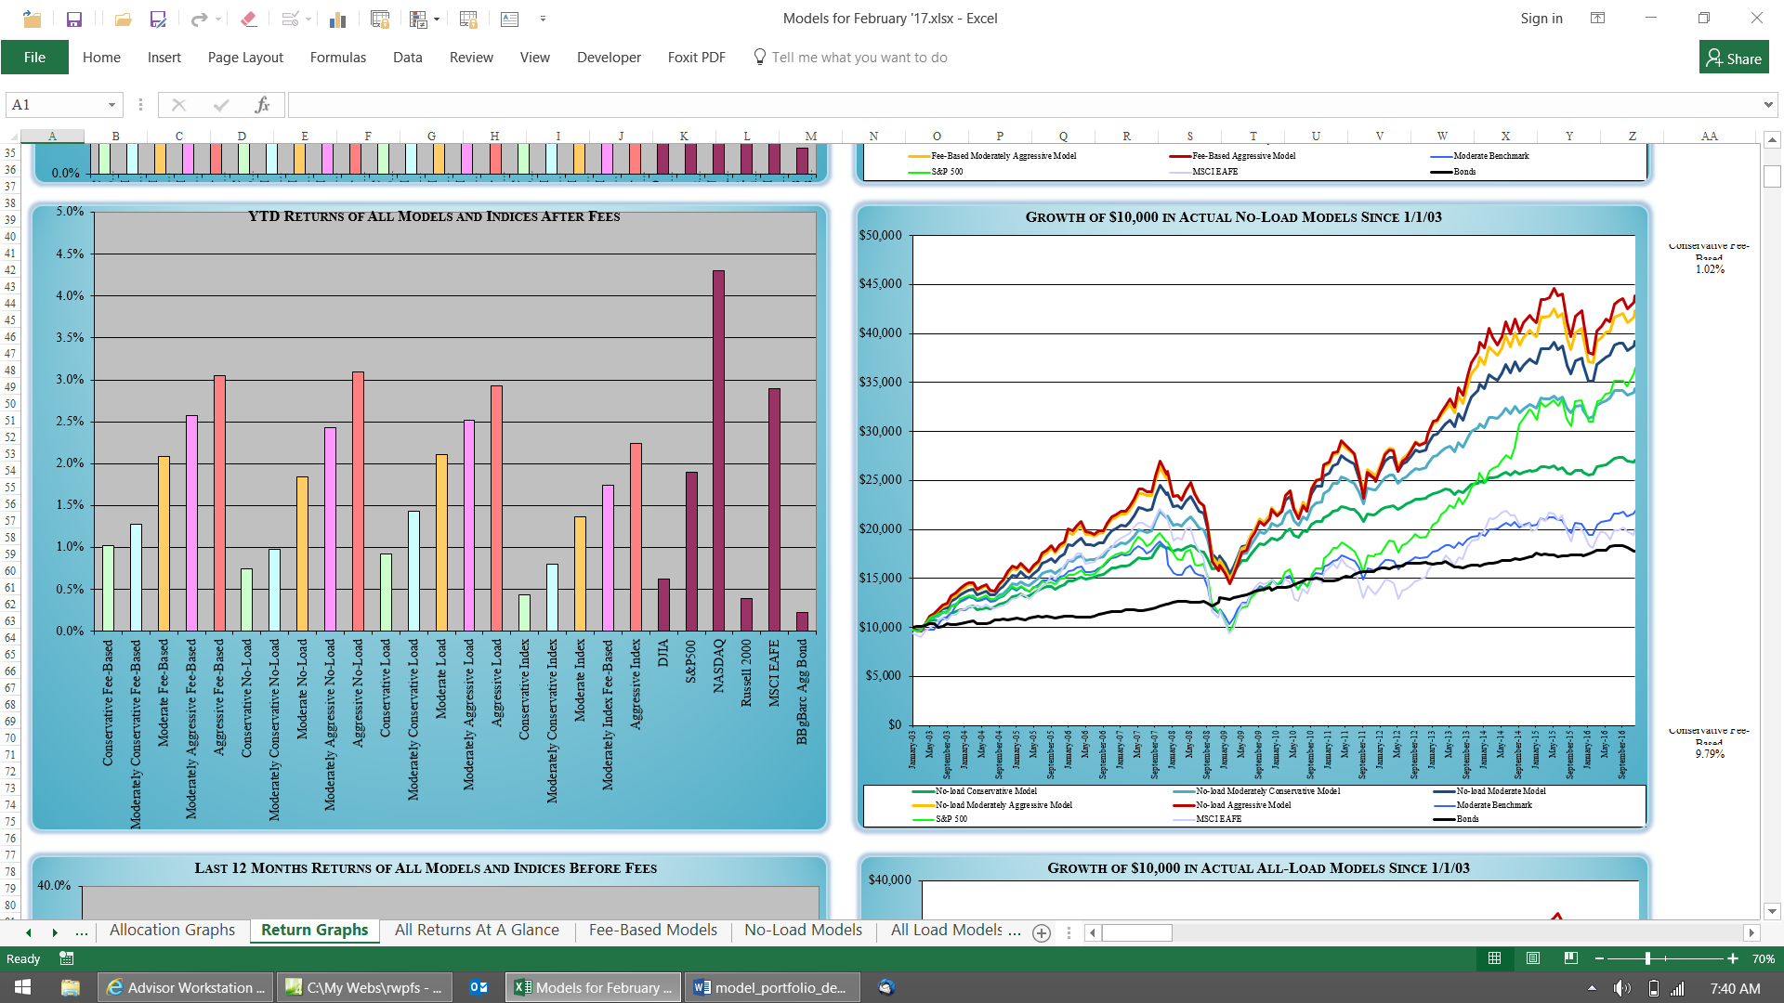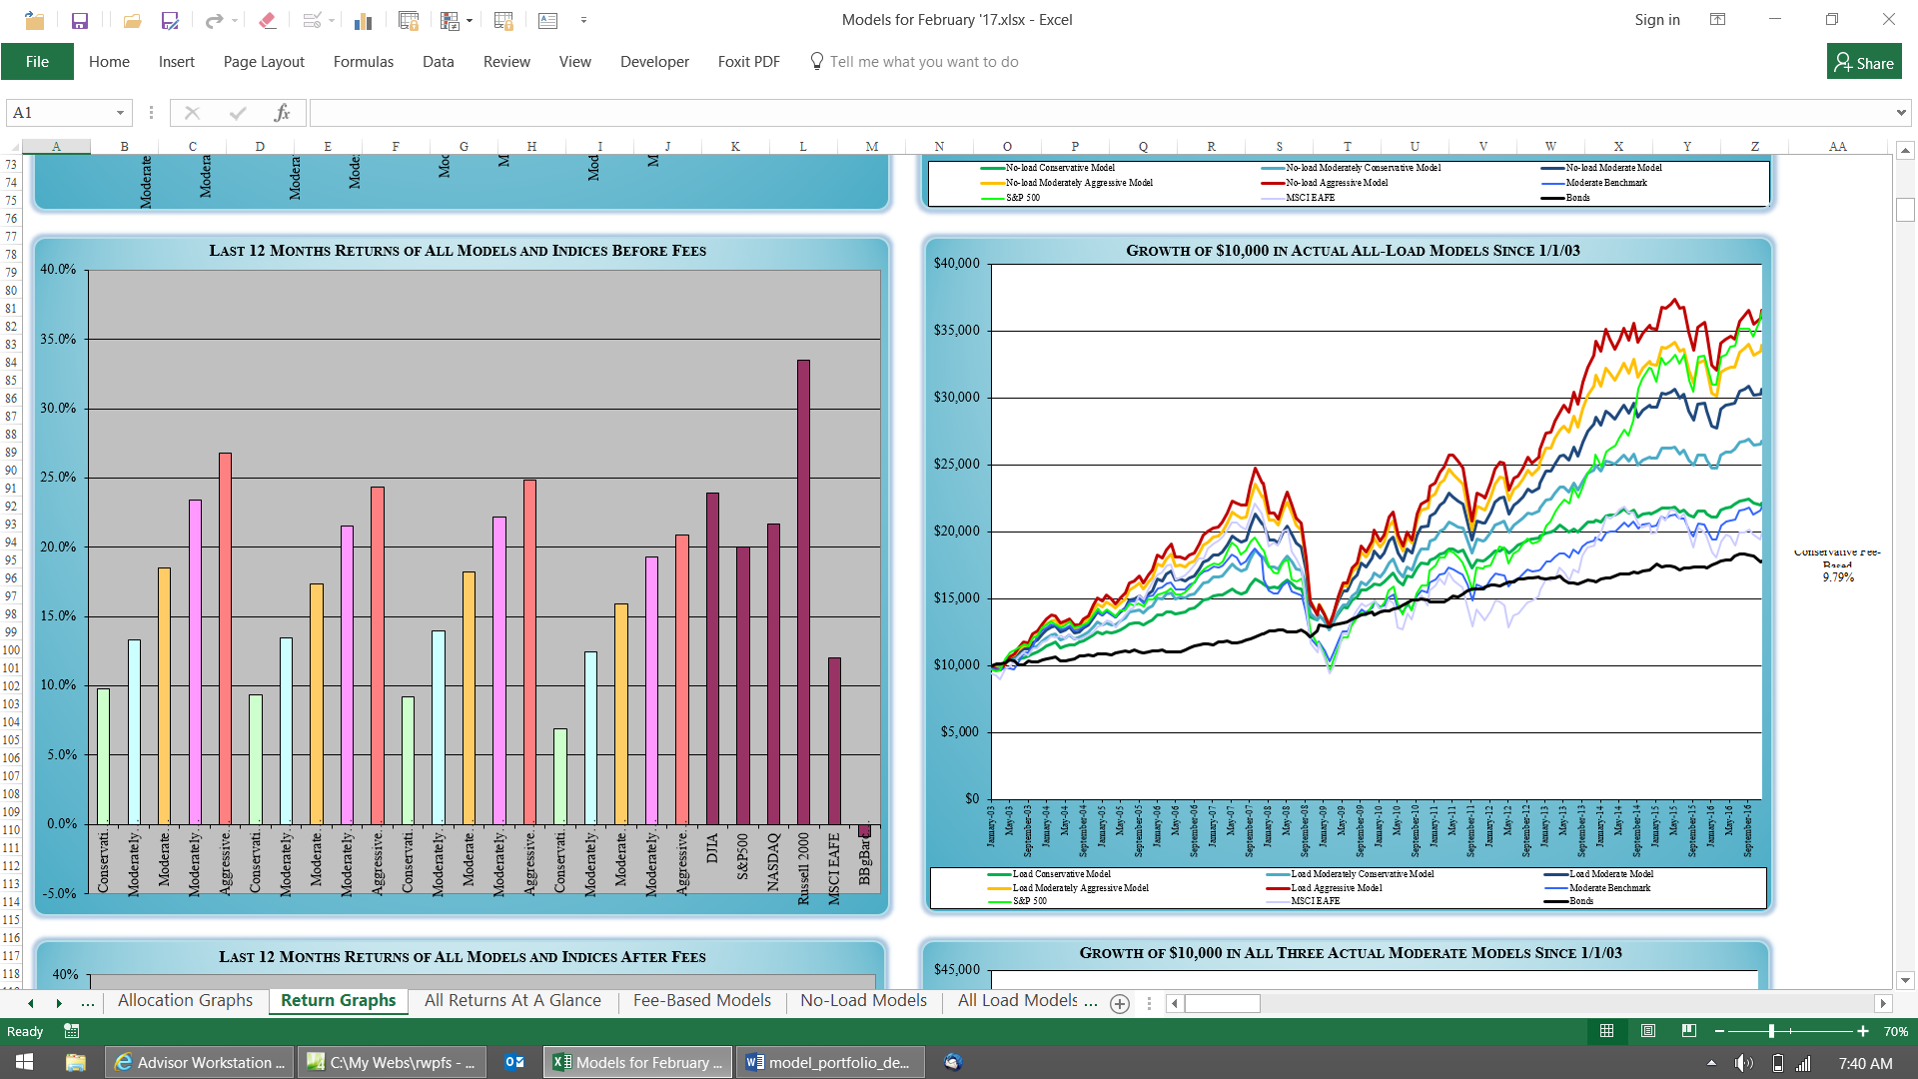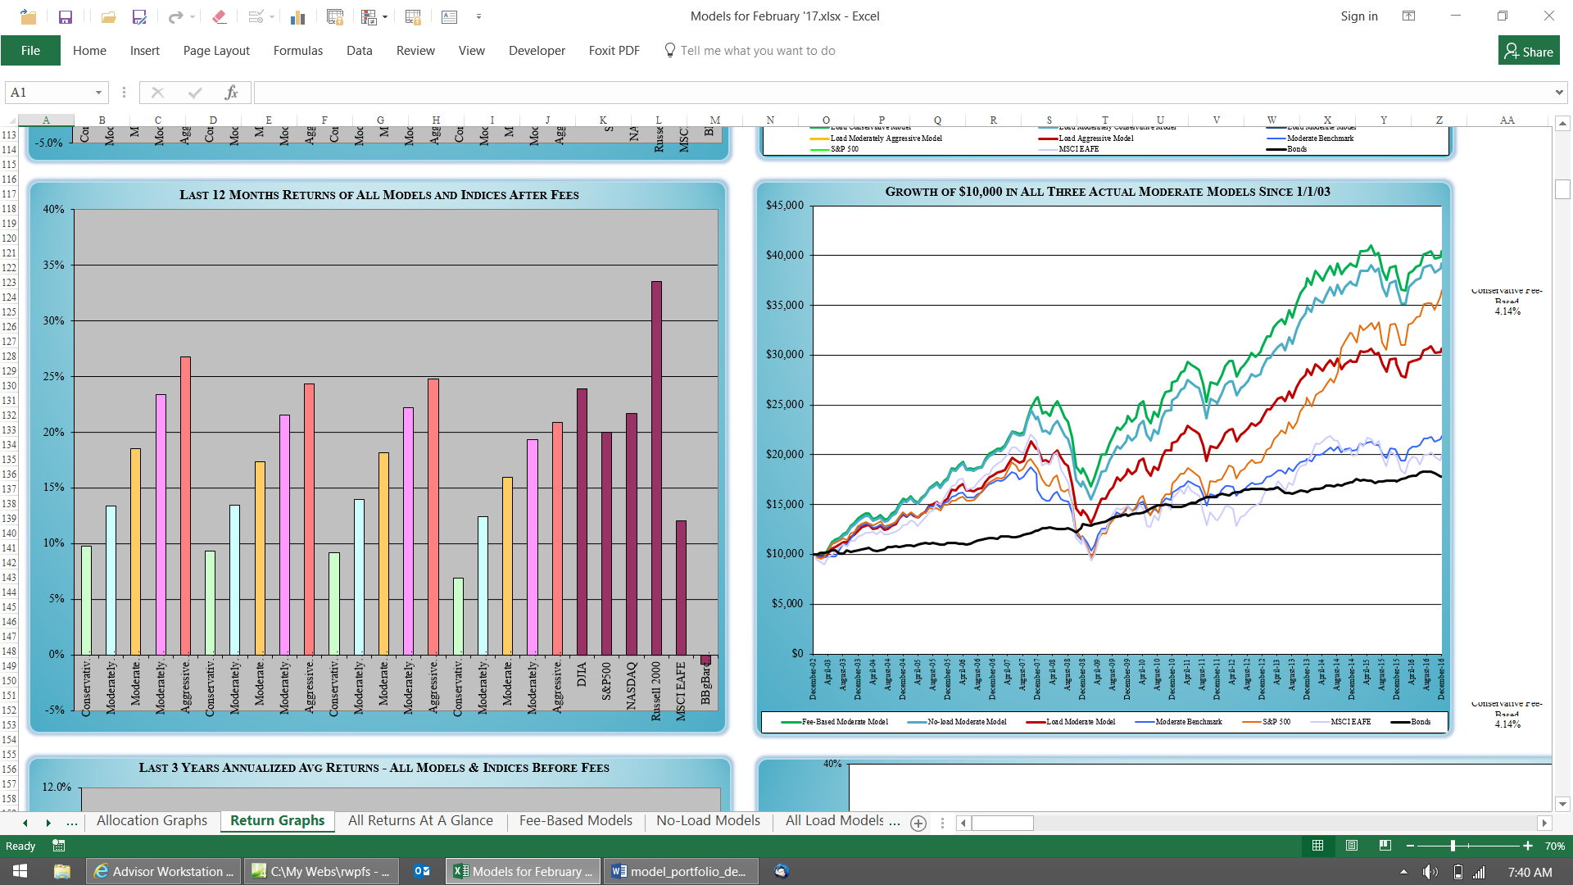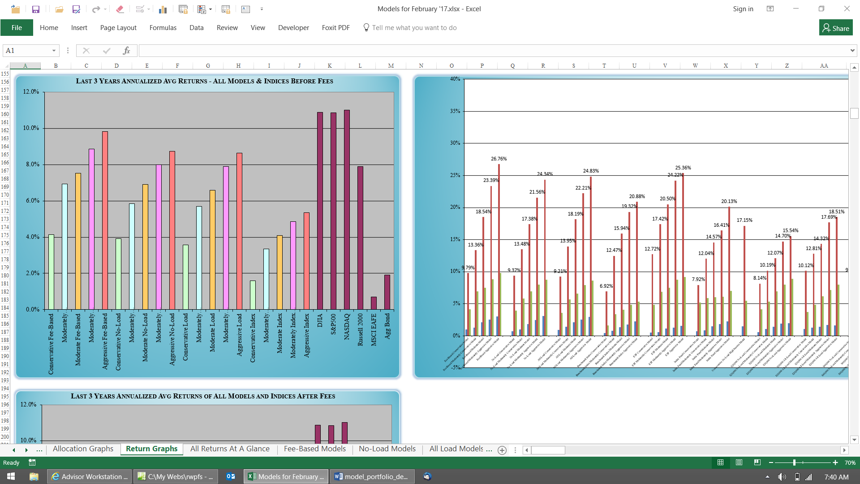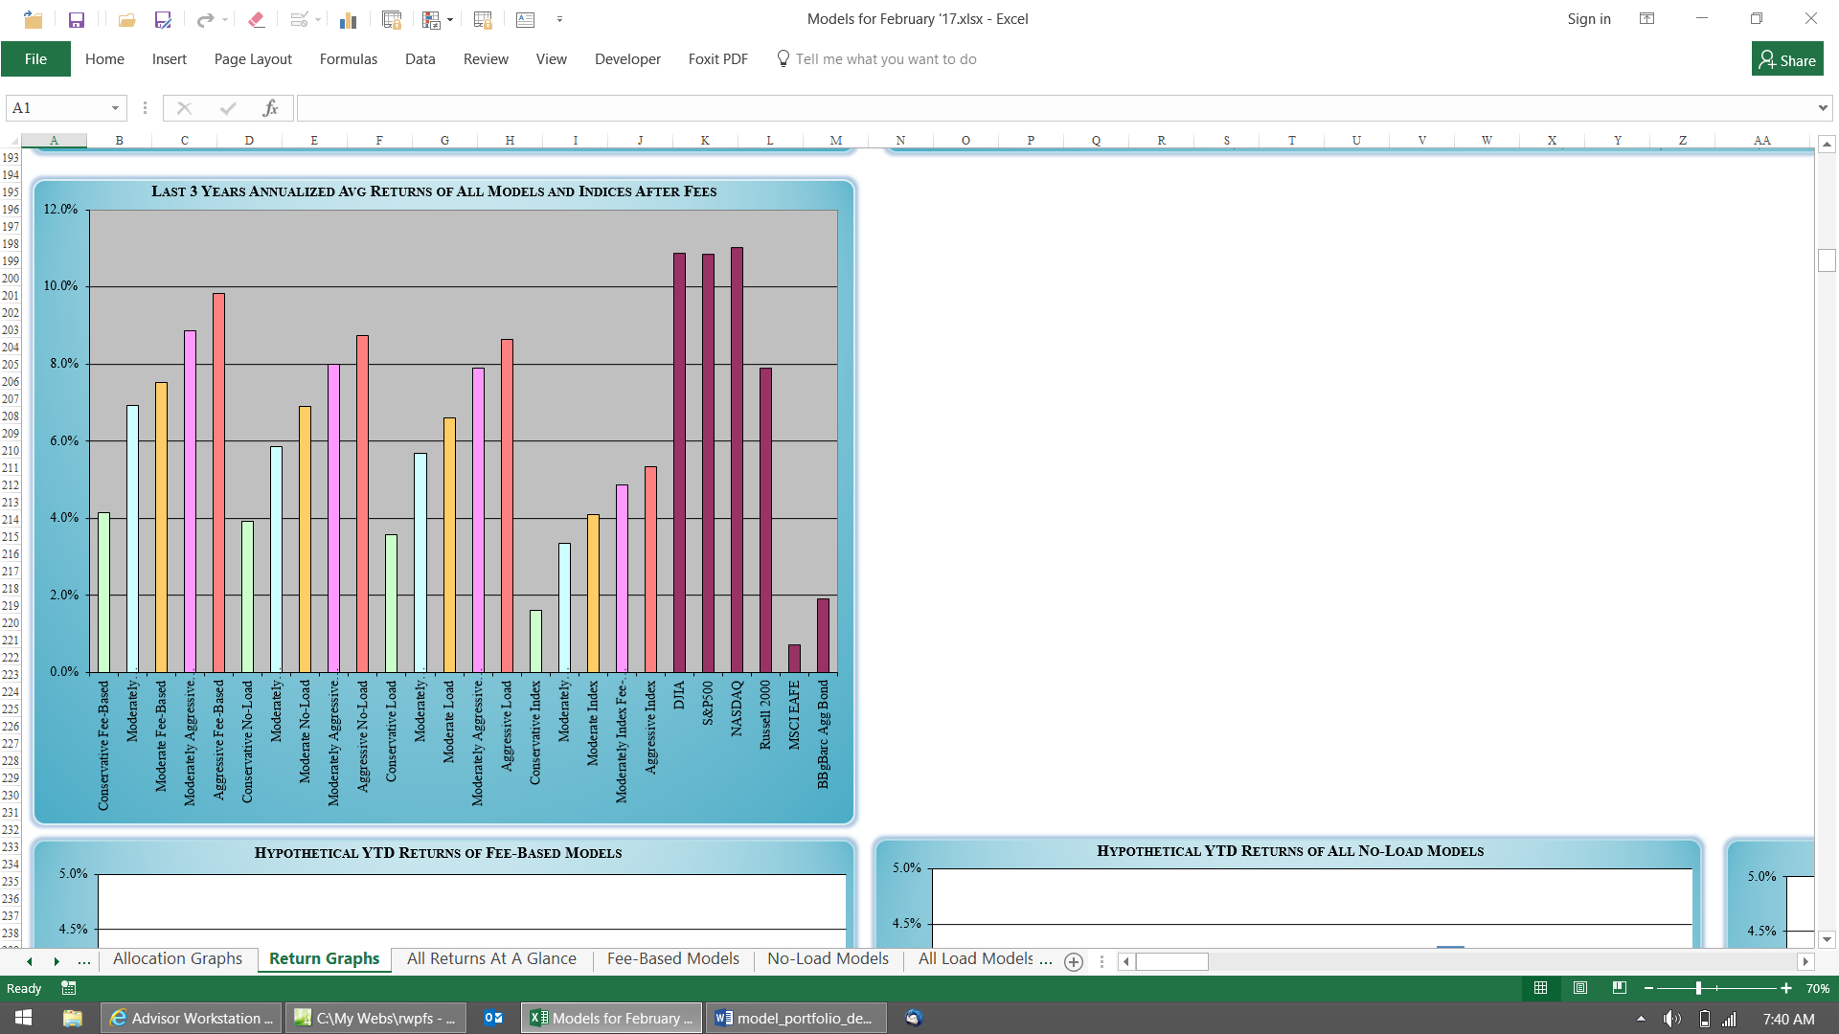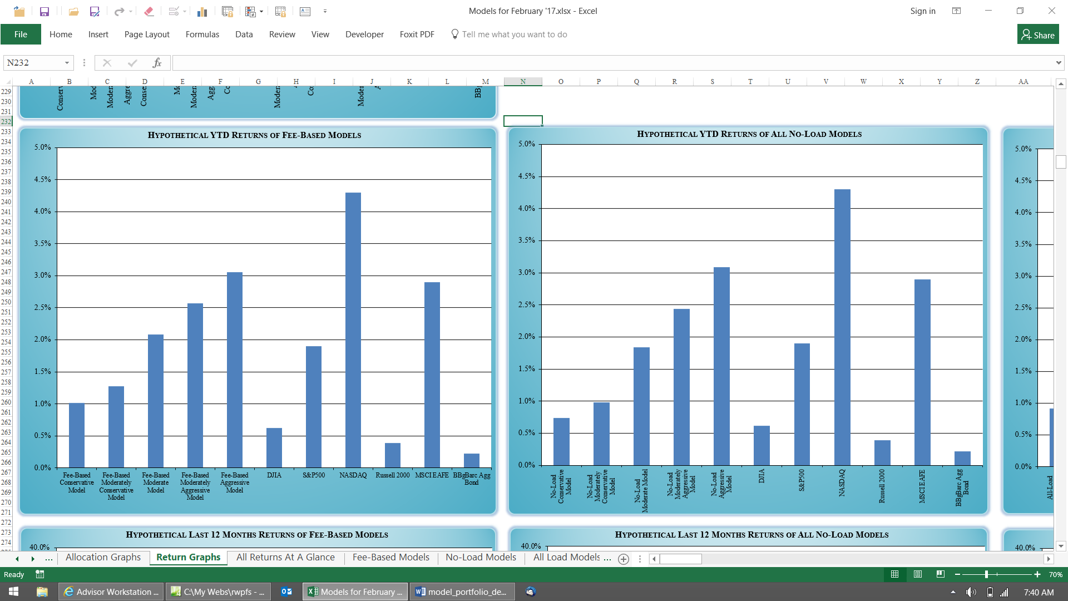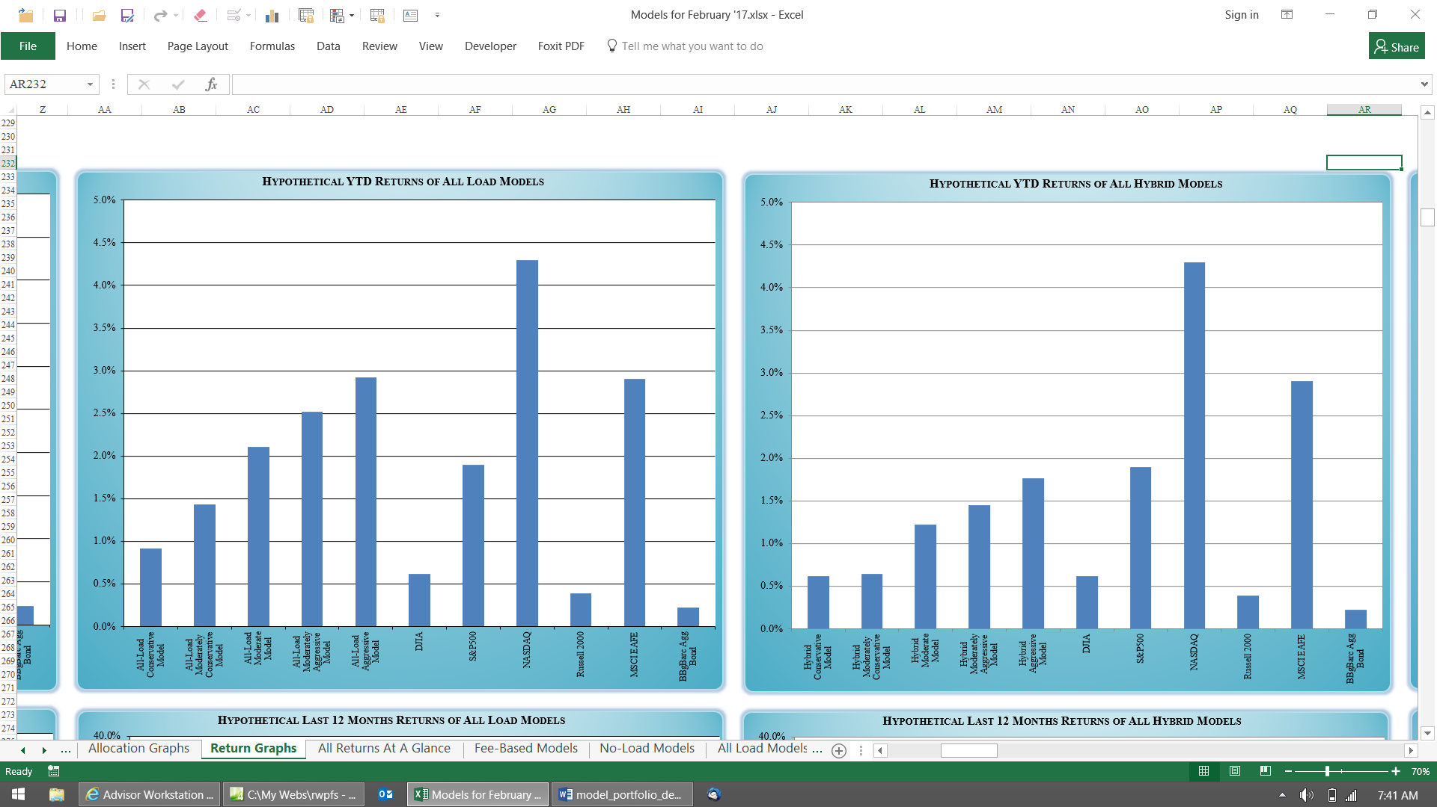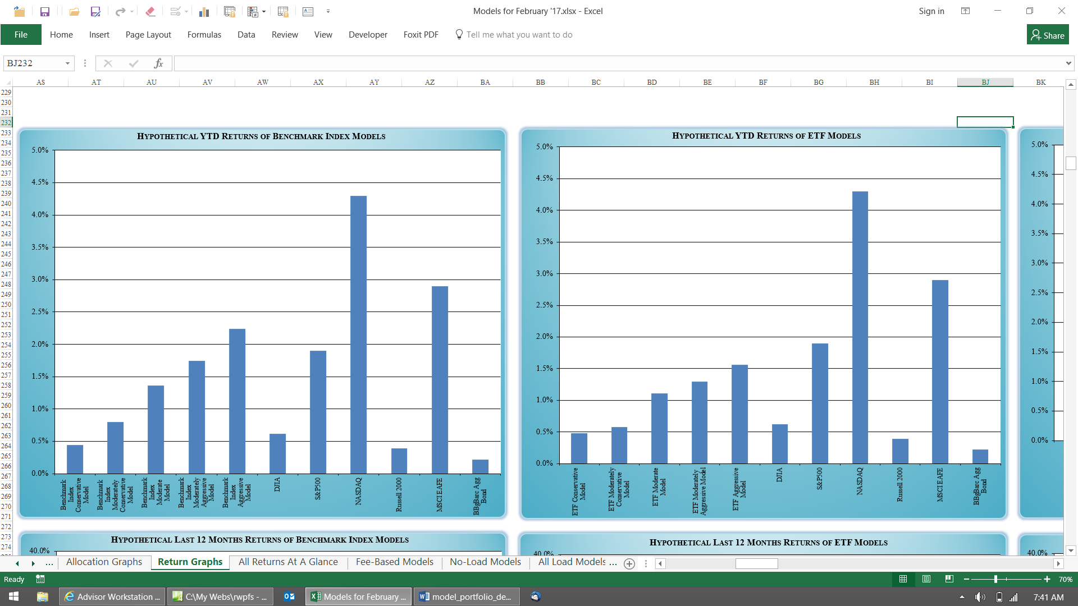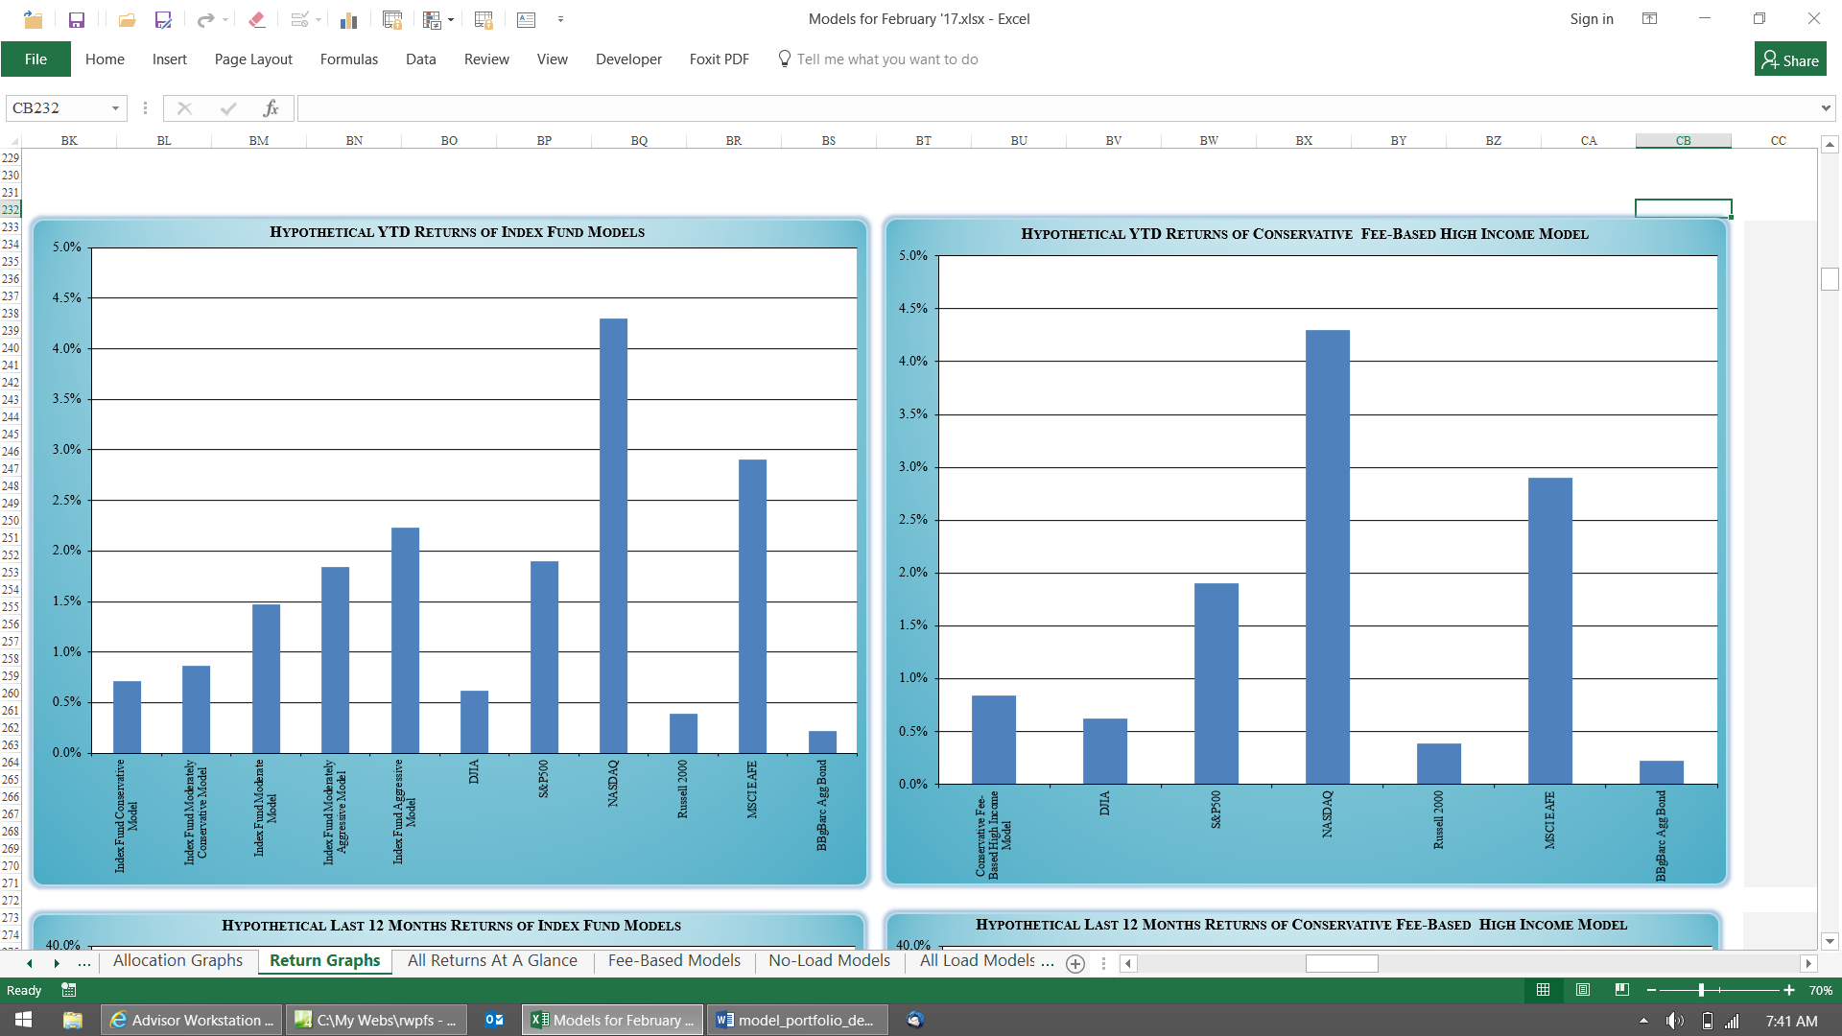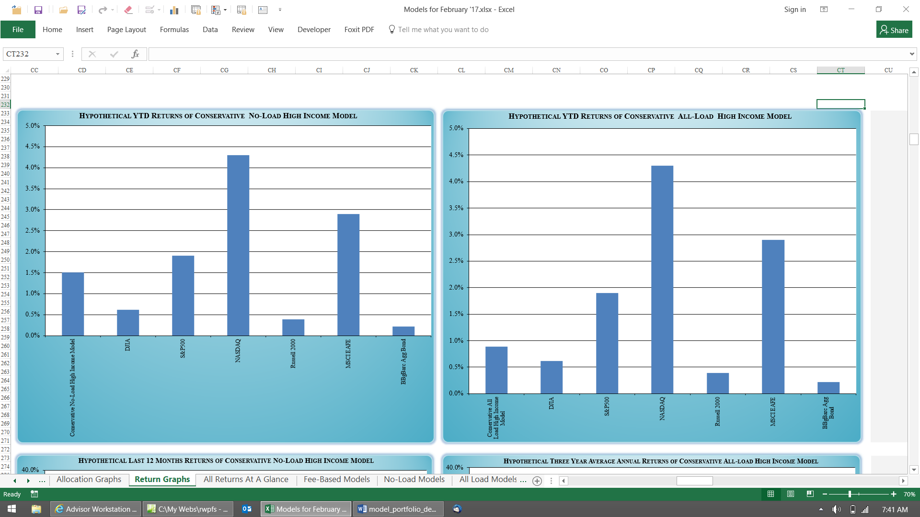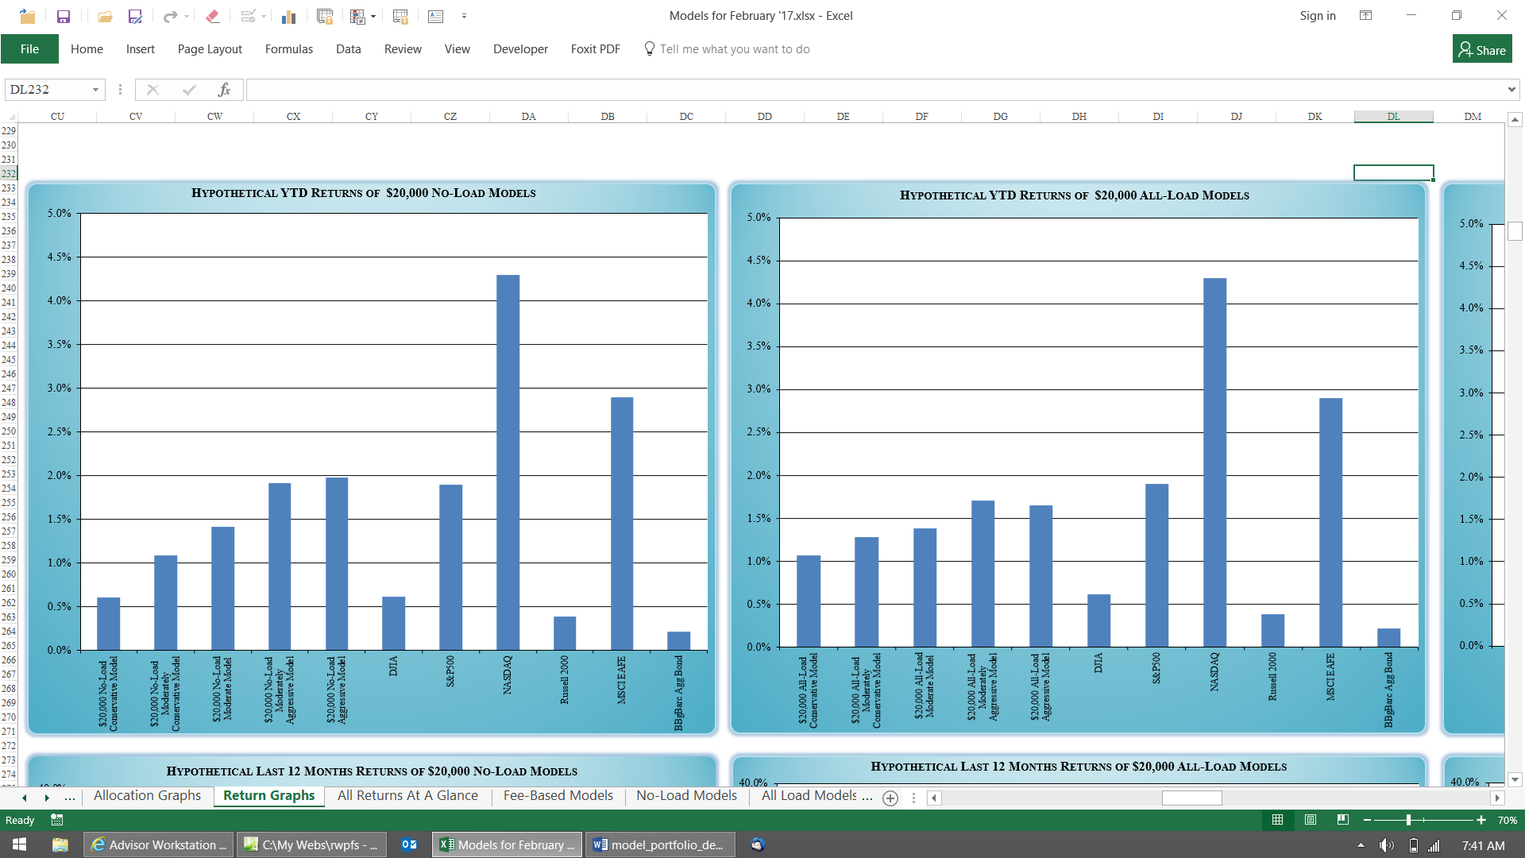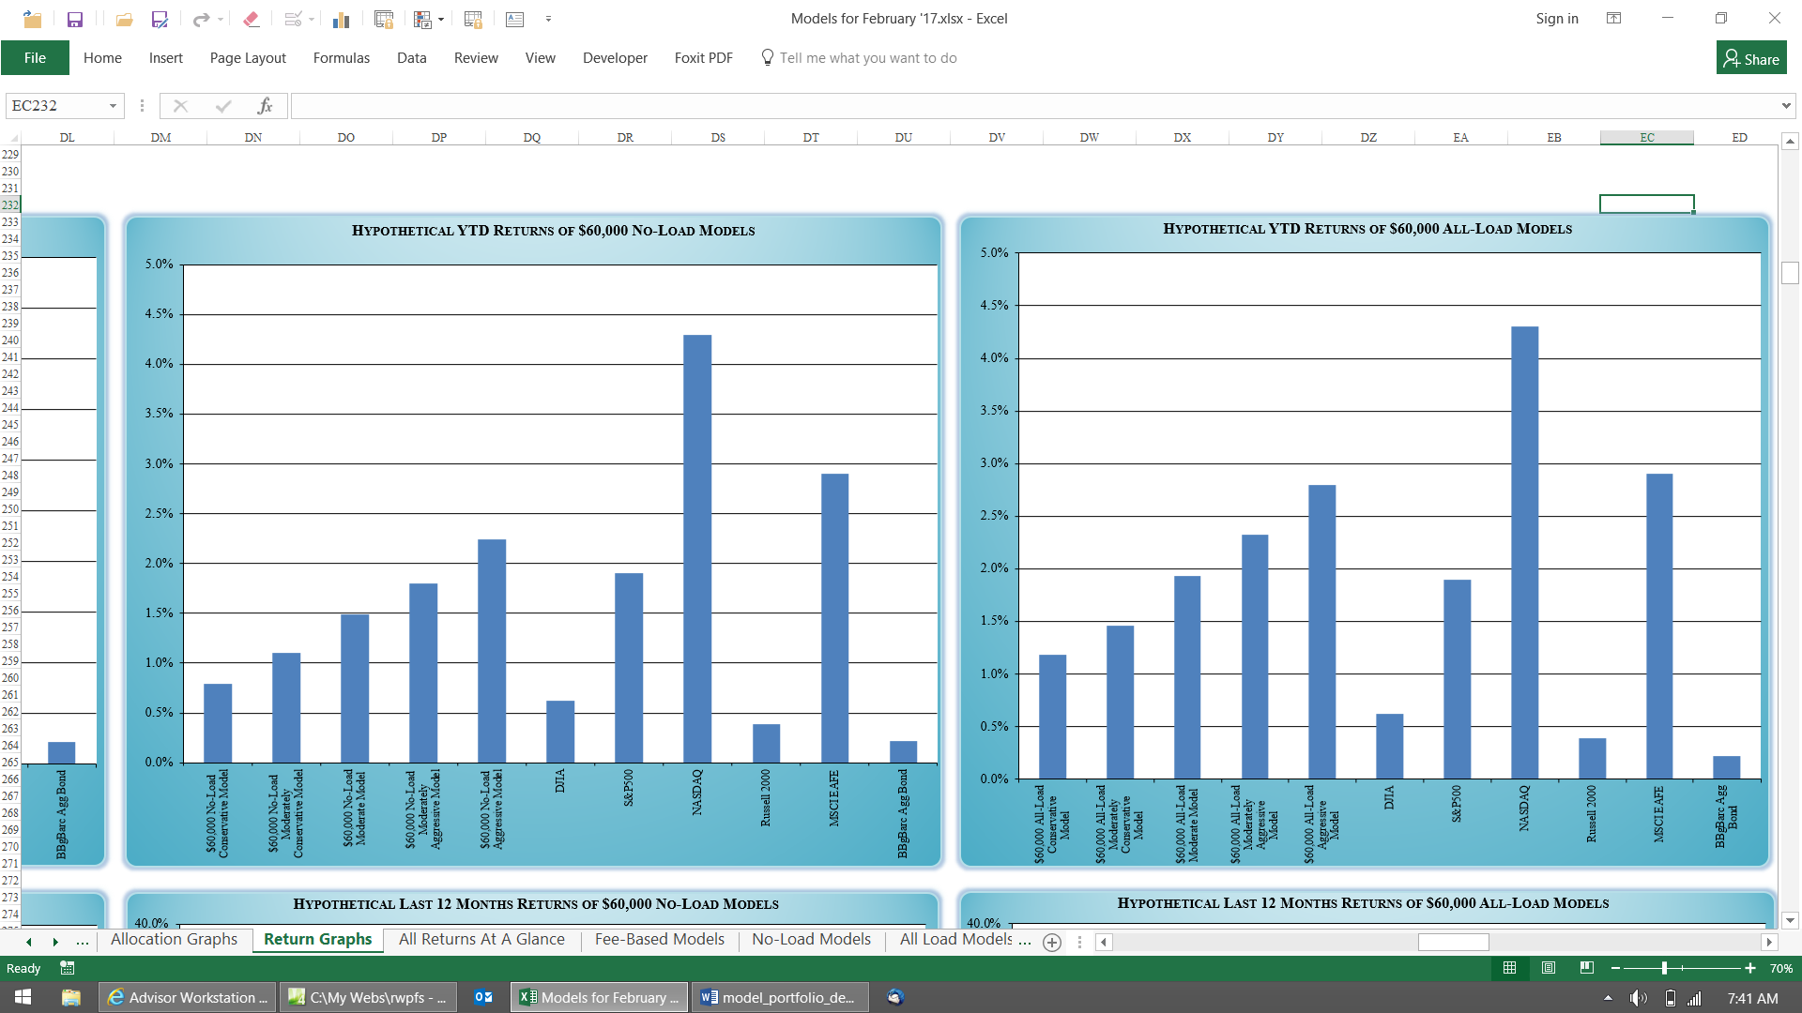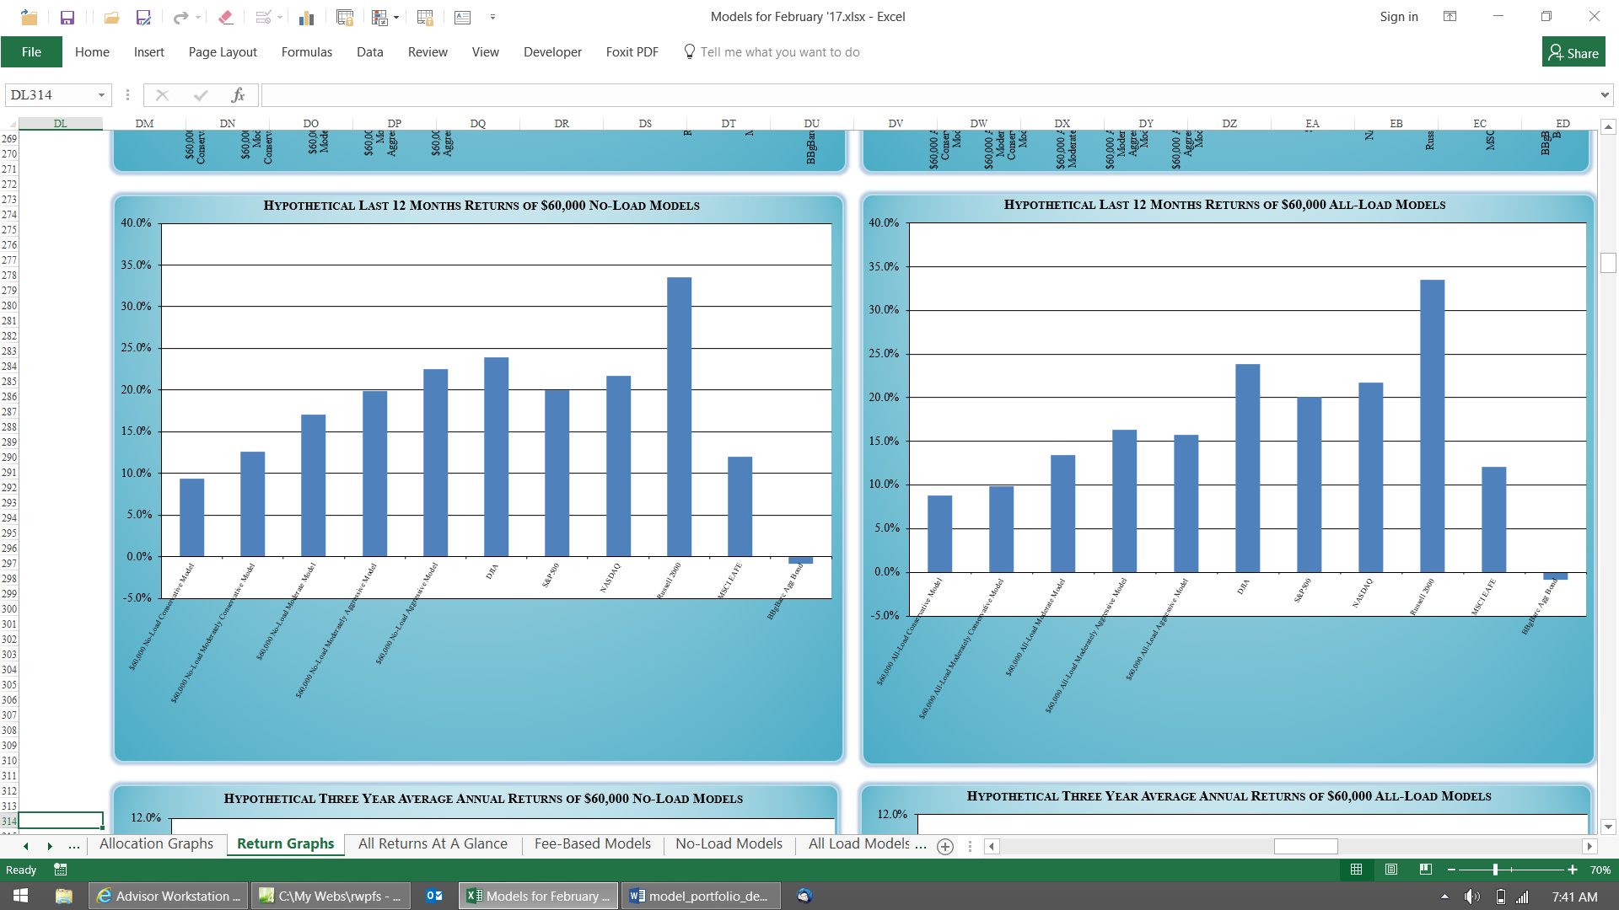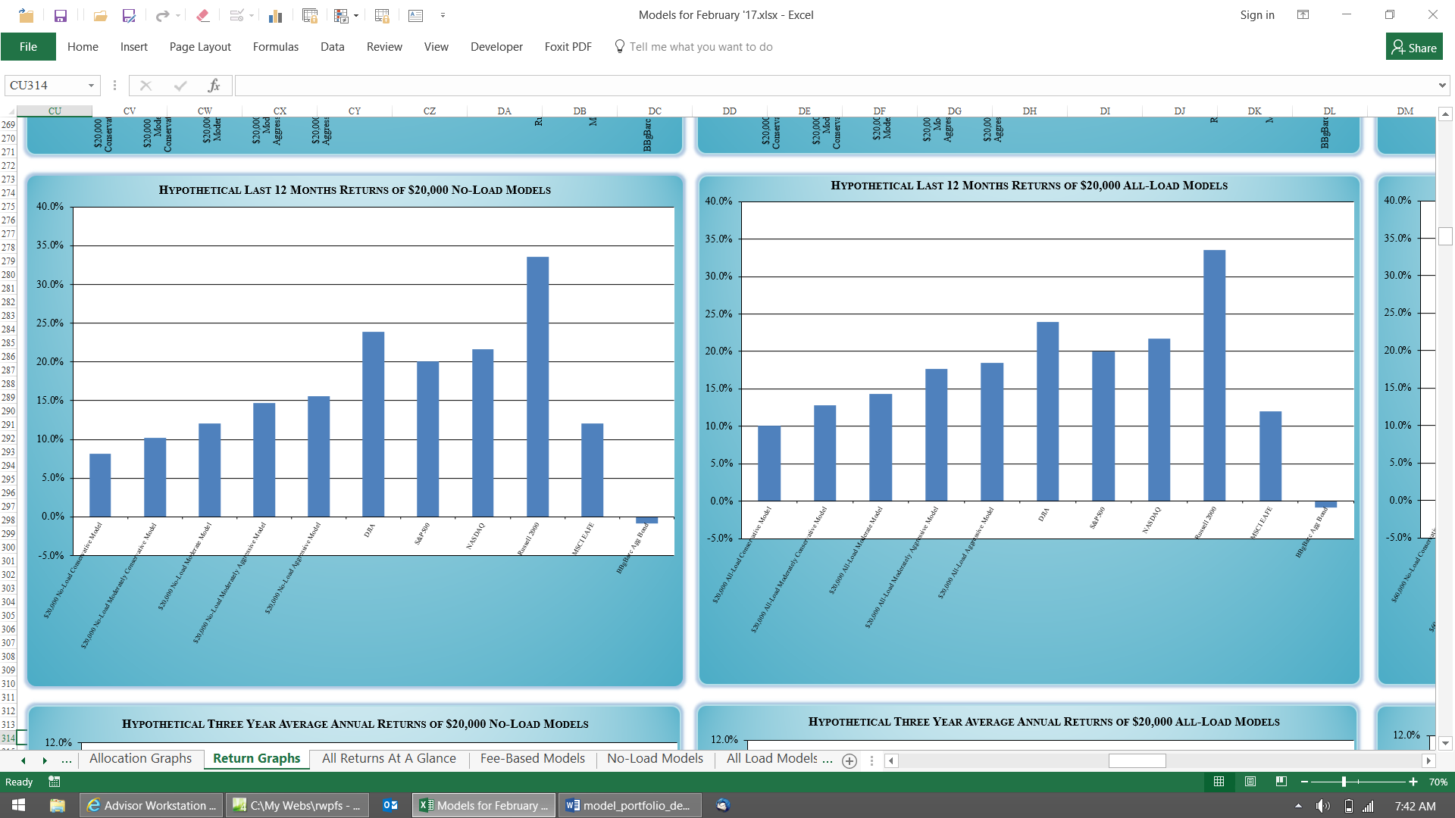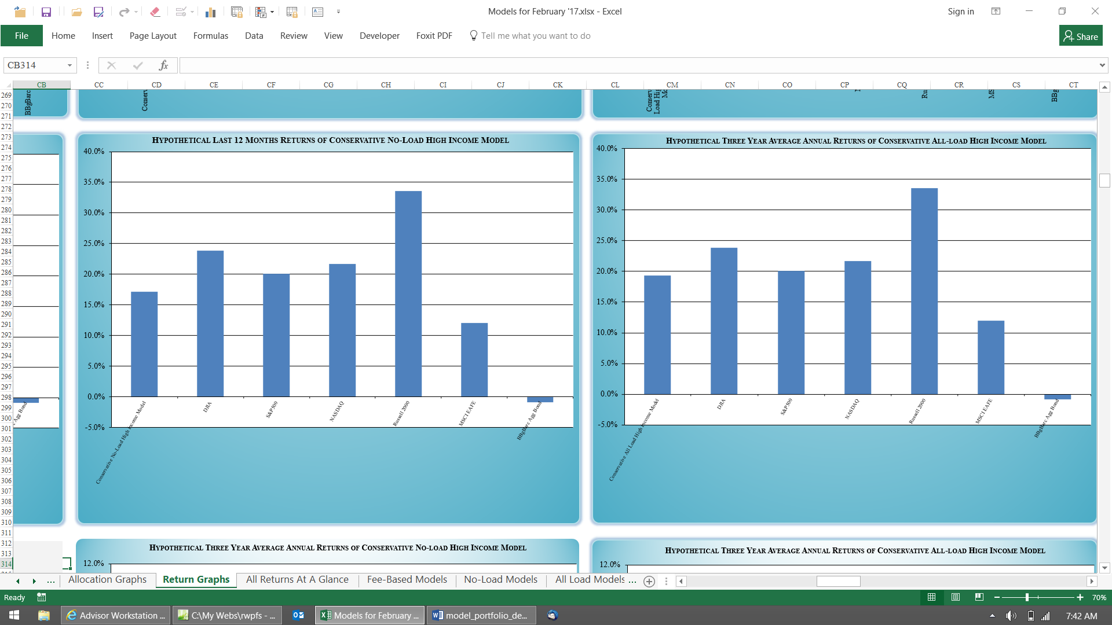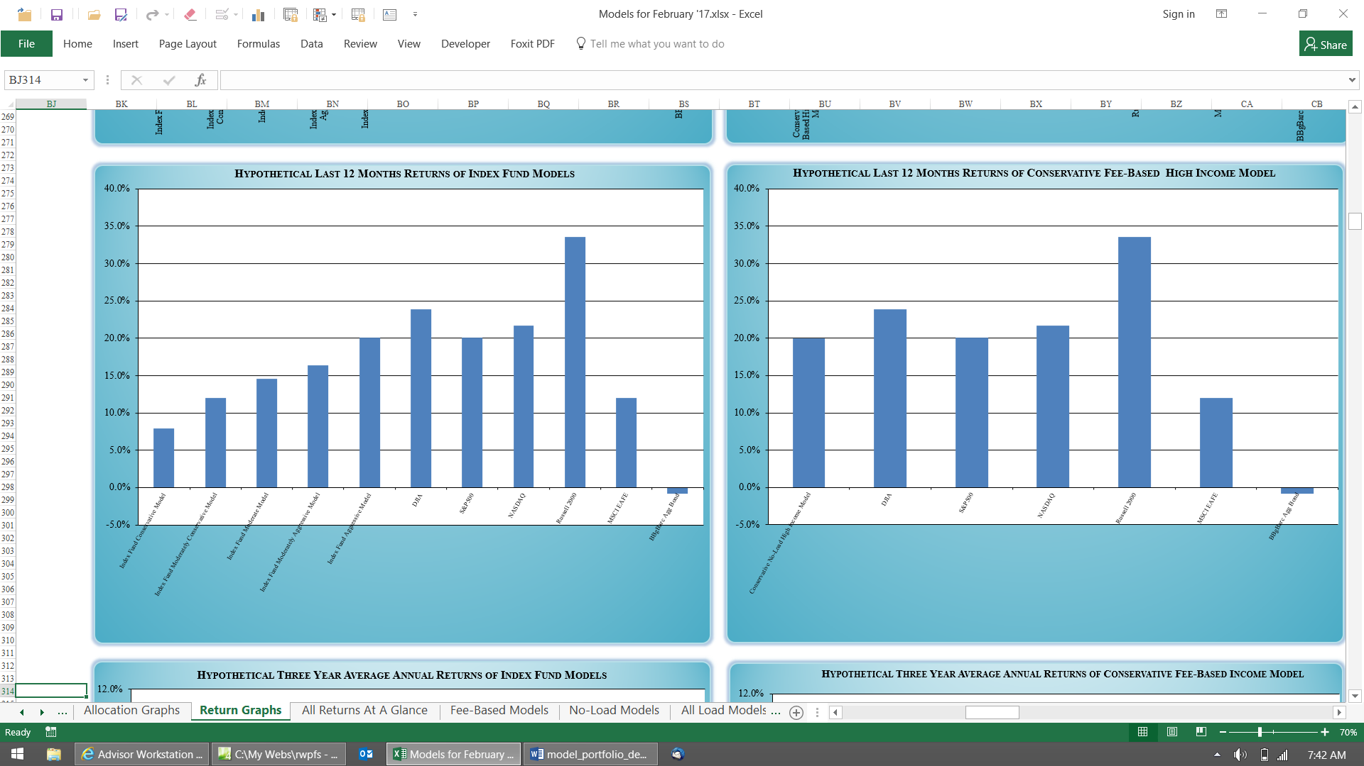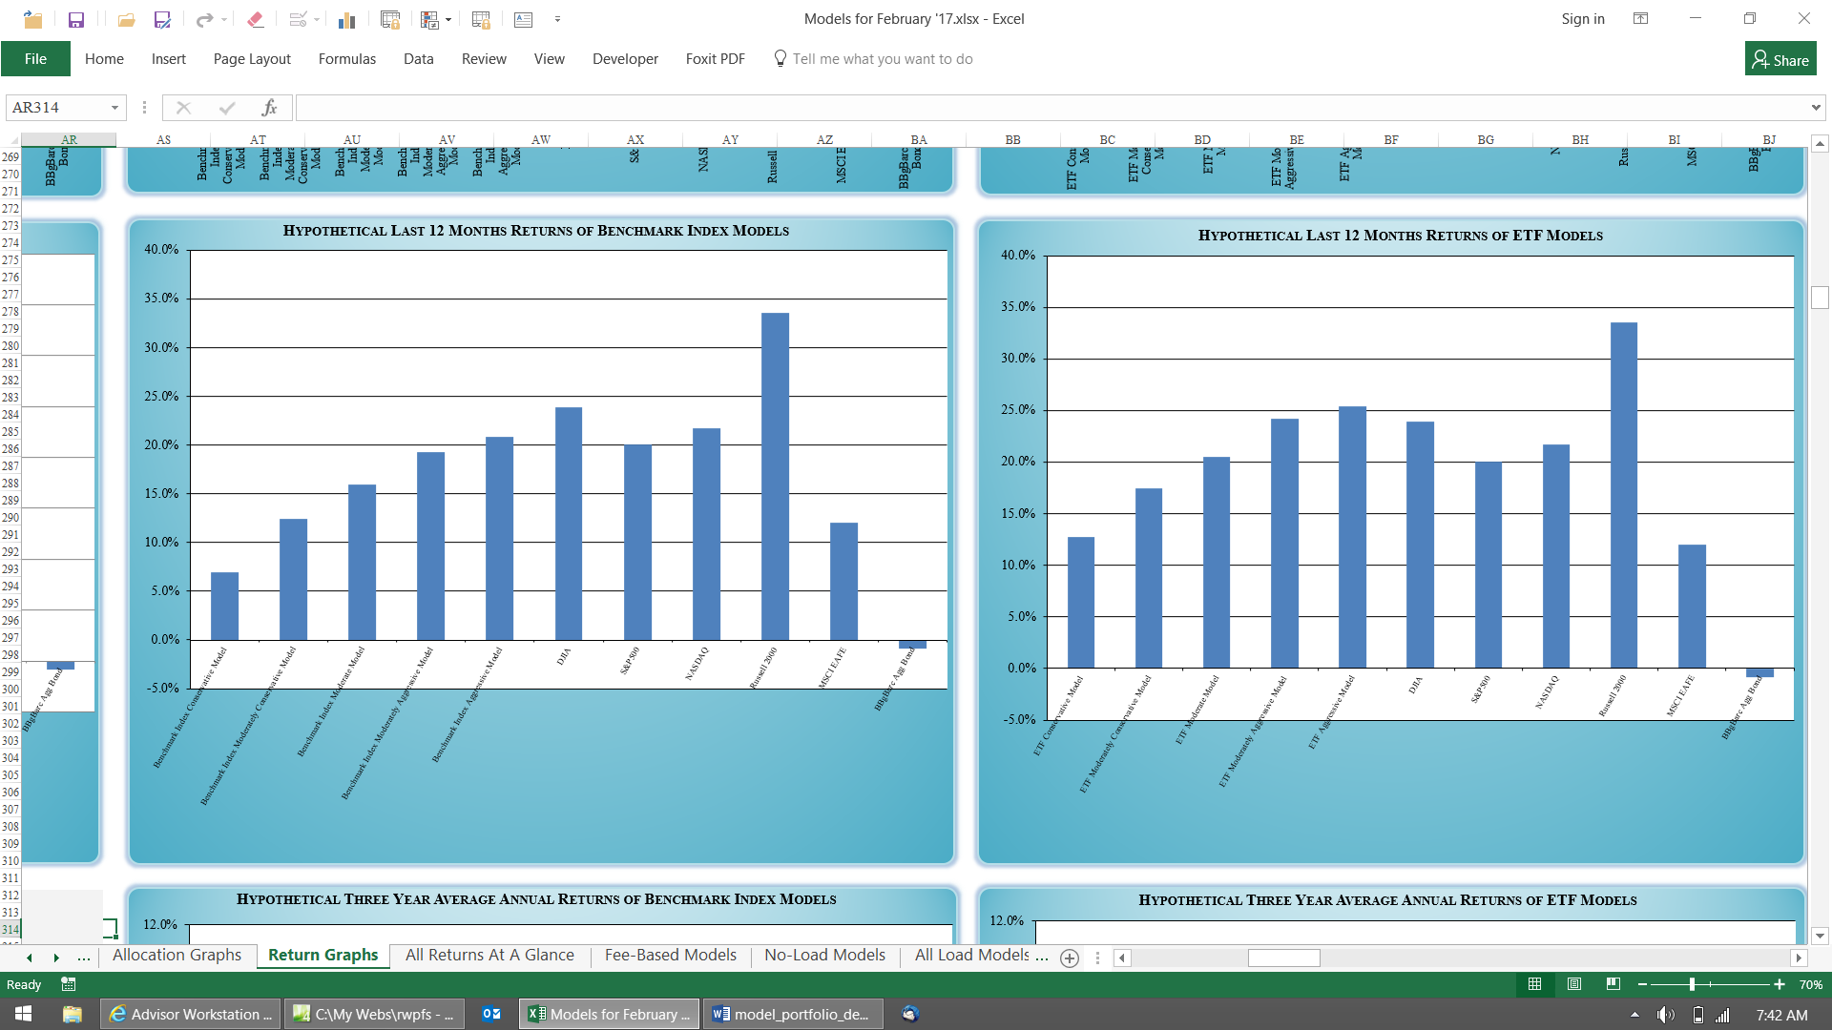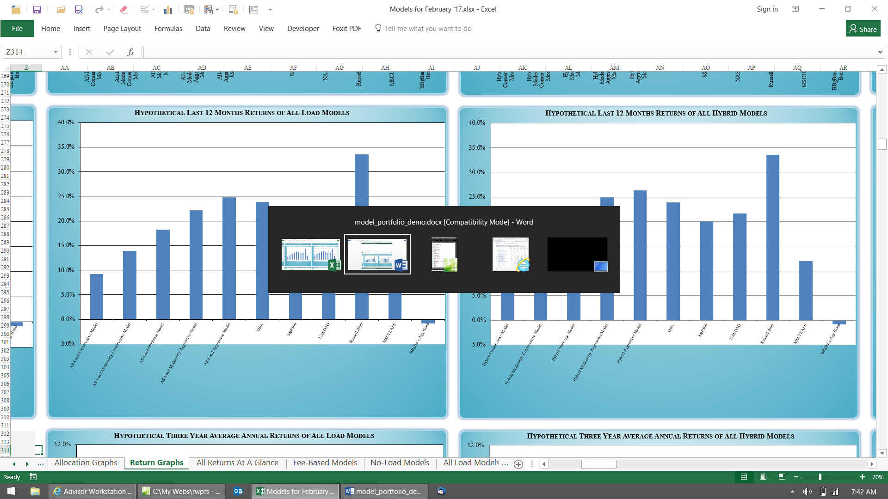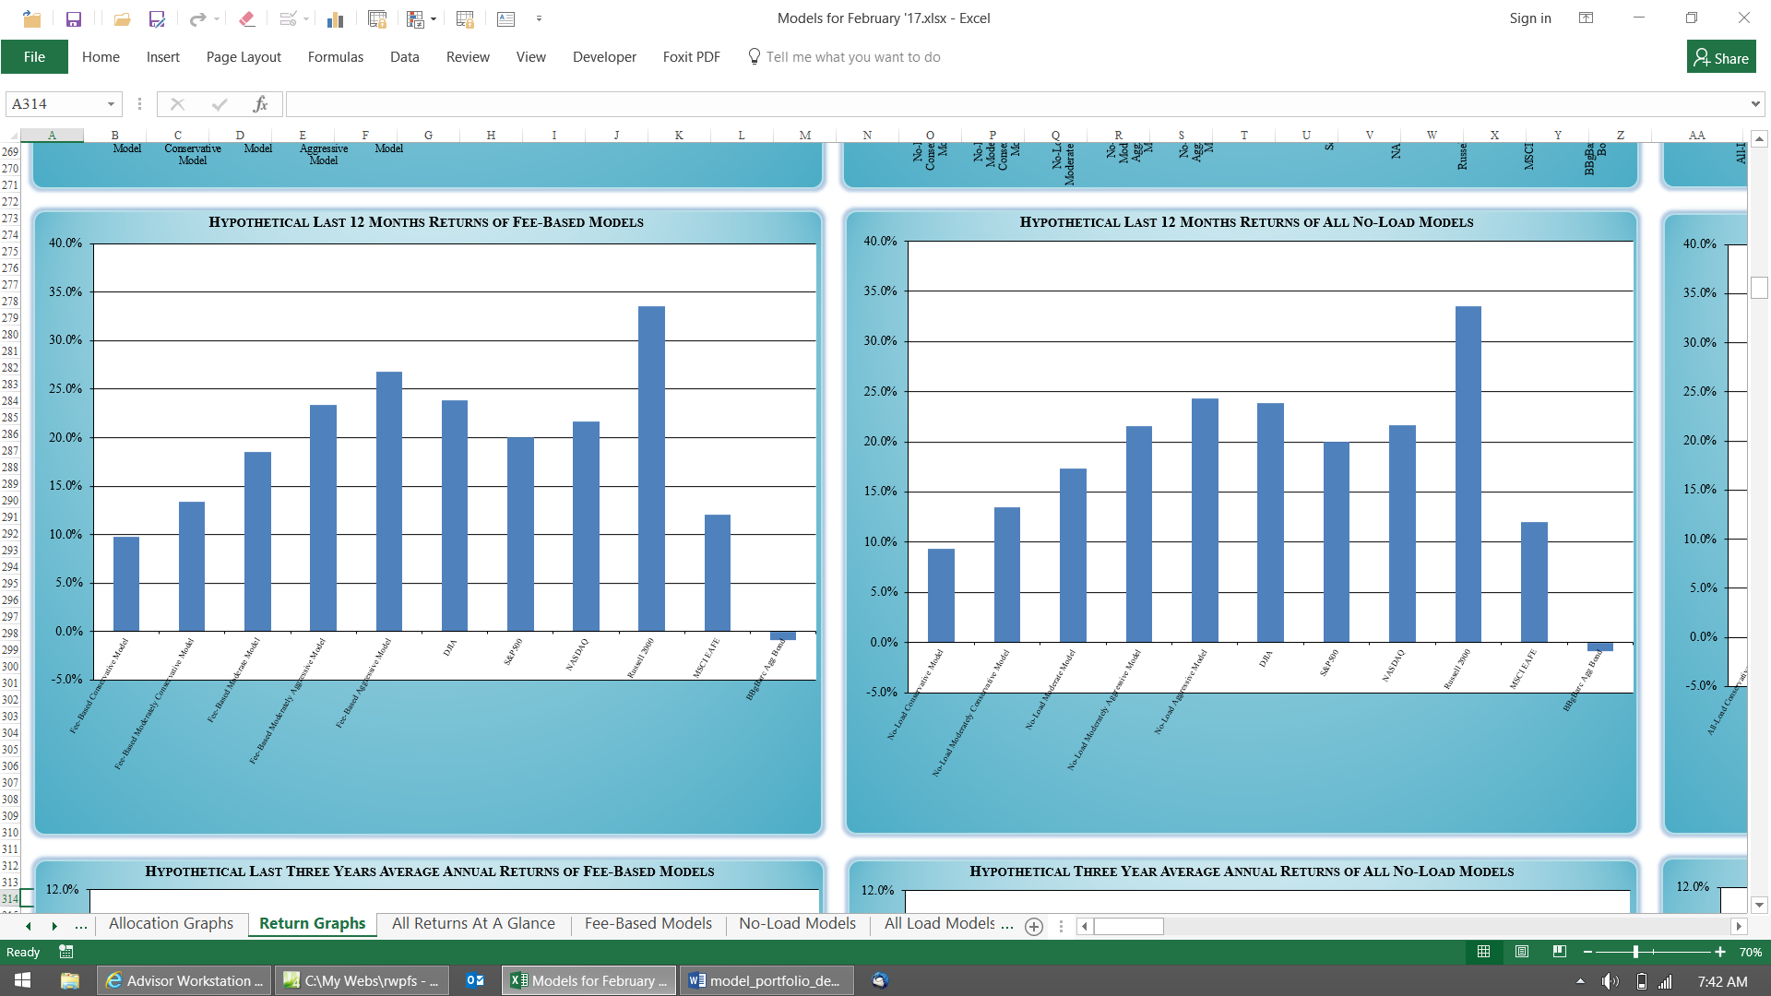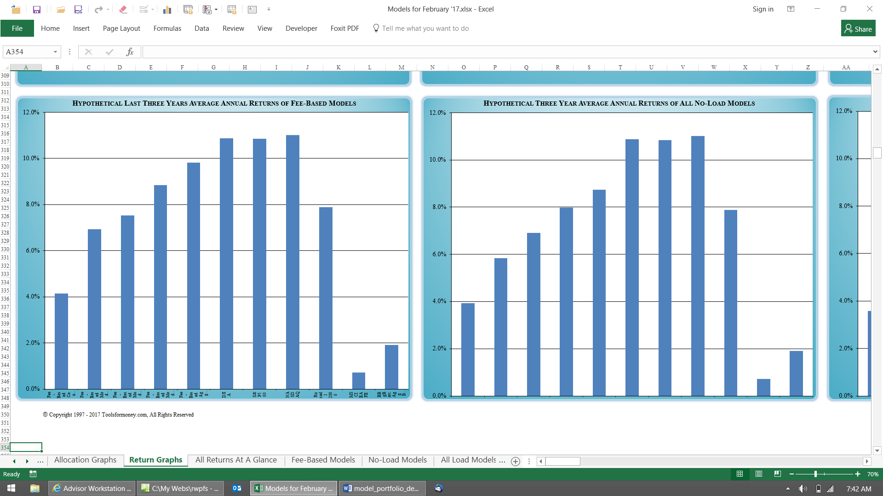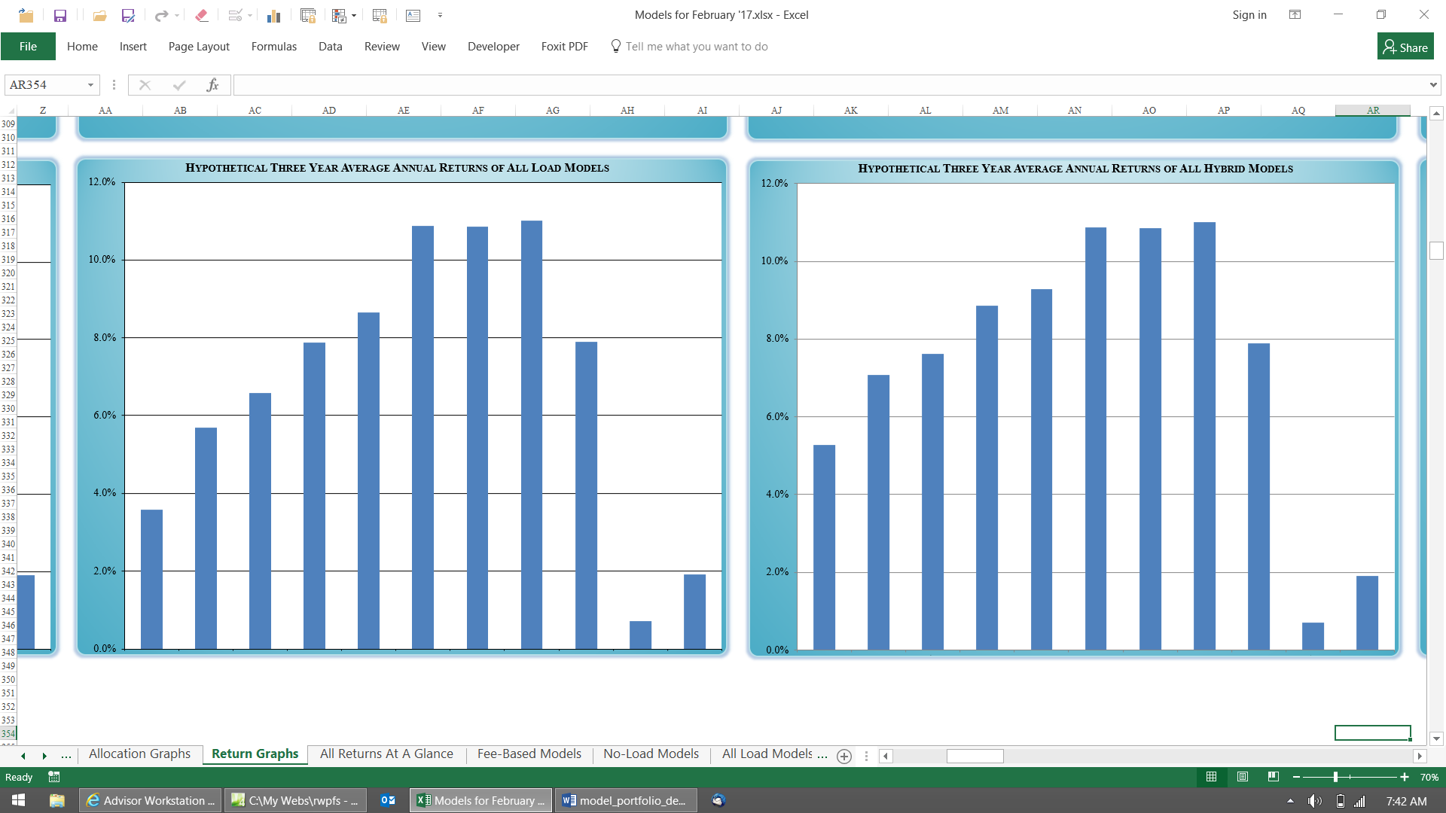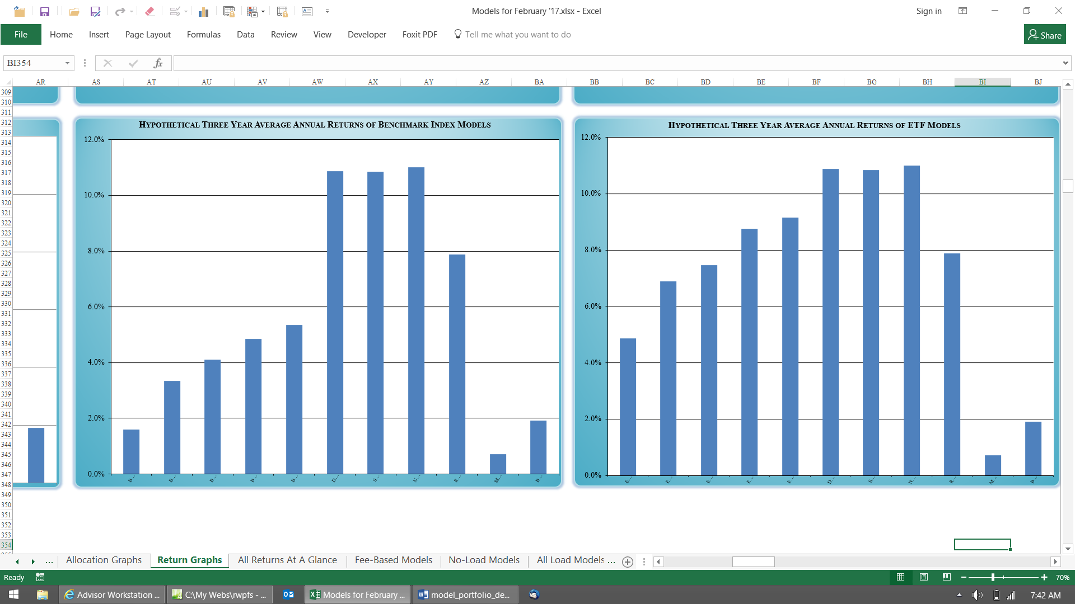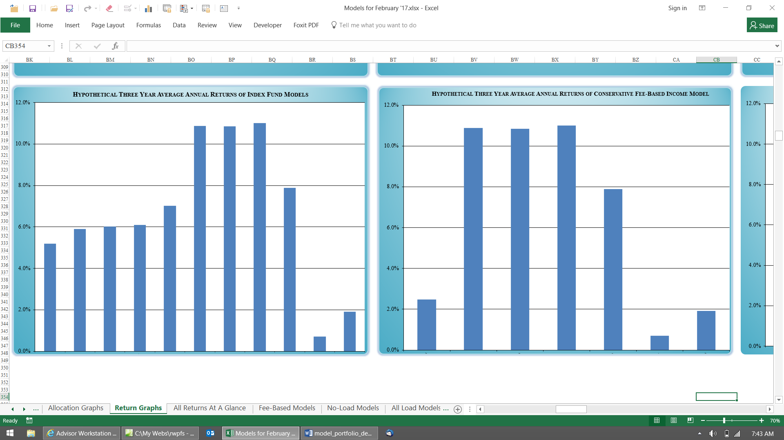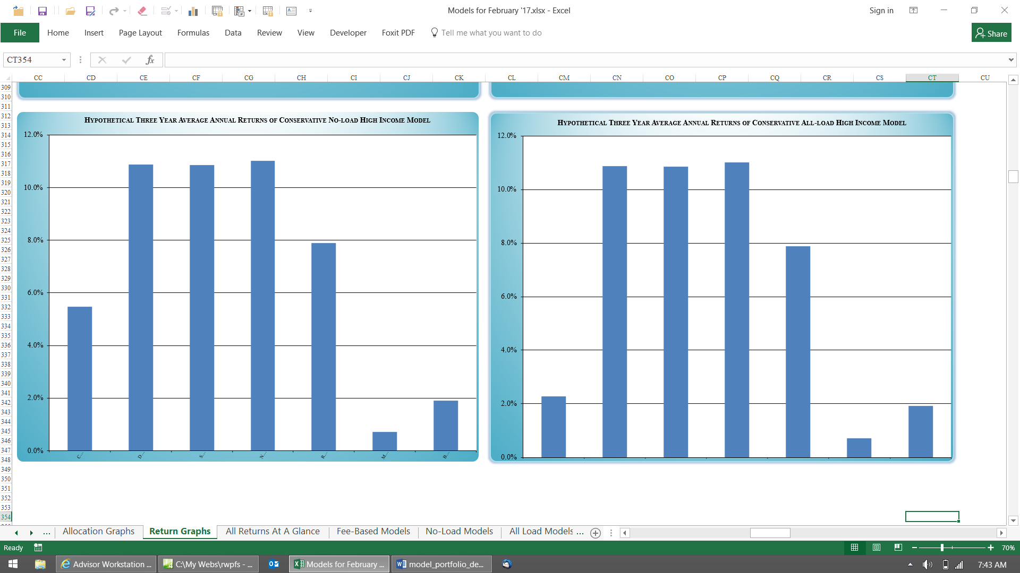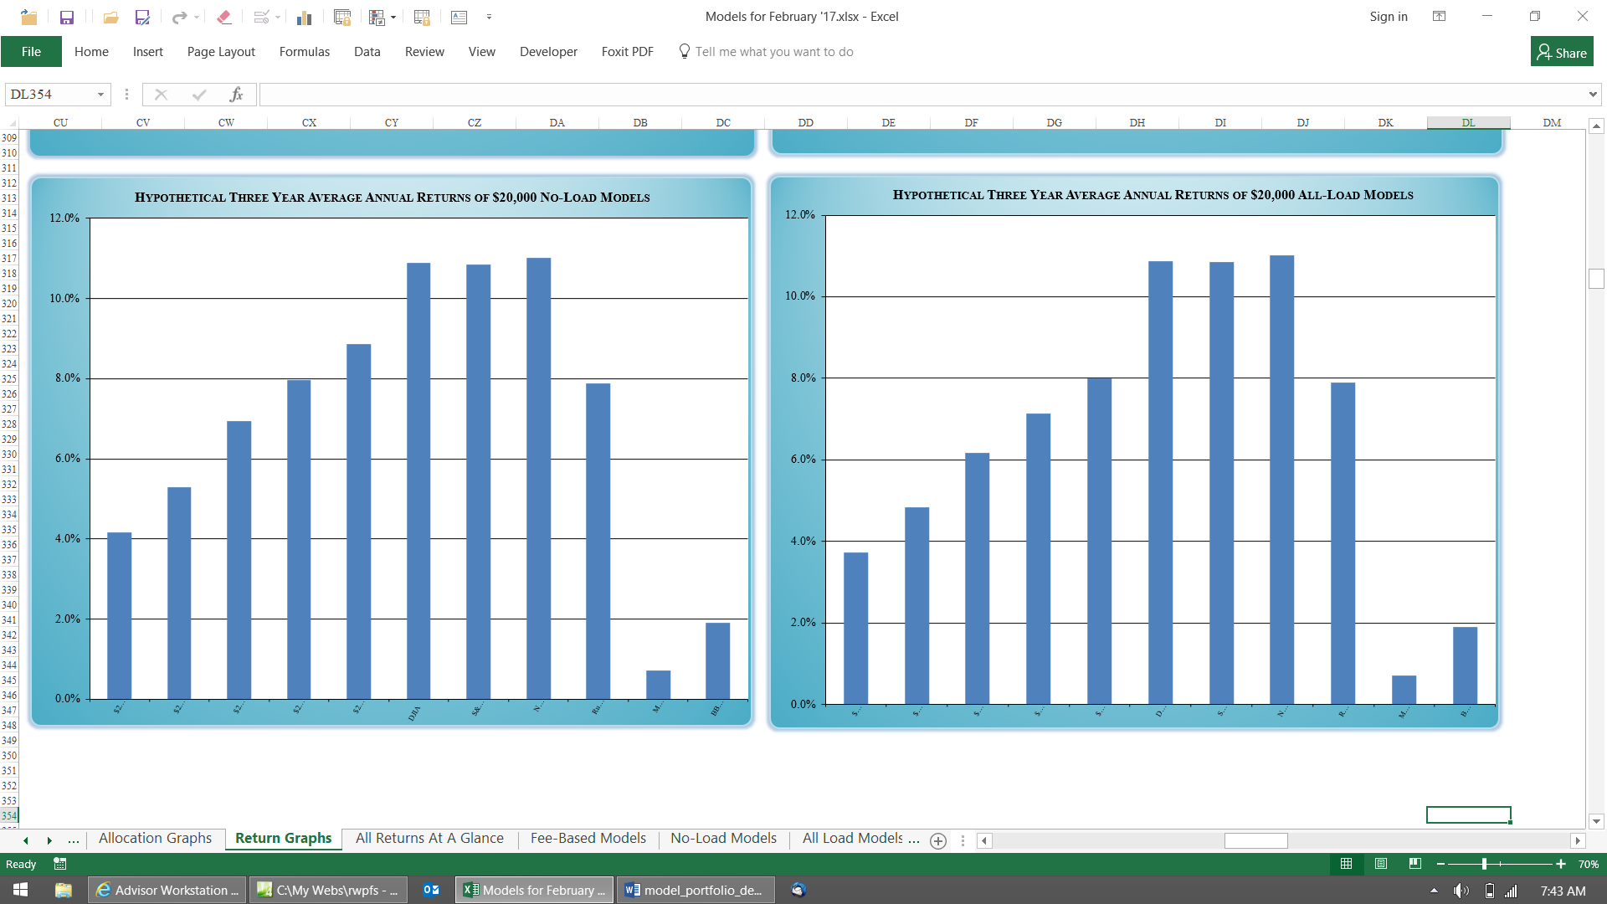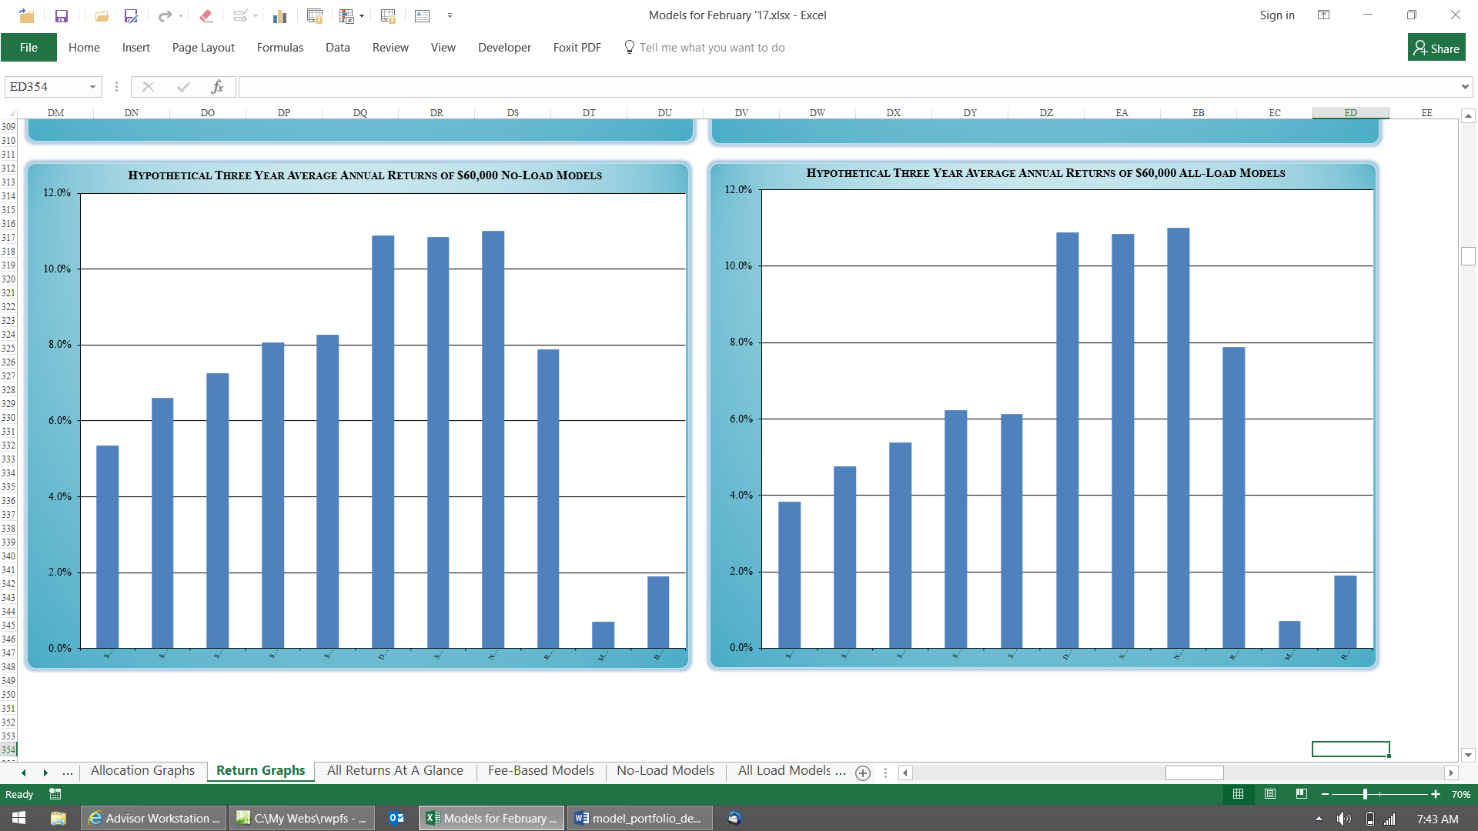
Returns both before and after advisory fees (individual DIY investors wouldn’t input advisory fees, so the two numbers will be the same, like they are here).
Portfolio’s yield and allocation weights using the usual five major asset classes.
YTD rates of return for some popular market indices for comparison purposes.
This column shows the allocation weights of each model. This is the only thing that changes between the five model allocations. The actual weights are not shown to protect content. You can change them to be whatever you want.
Mutual funds are used to represent each asset class. Get updated default suggestions from this website. You can use whatever you want to fund the asset classes.
If you want to modify the Models, or keep them updated more often than monthly, enter the returns of the mutual funds here. If you don’t then there’s no need to change anything, as they are sent with this updated data. Get the daily returns online or from the newspaper, and the 12 months, and three-year returns, online, or from something like Morningstar. You only enter them once here, and they filter through to all of the other models.
Asset classes used.
used.

